Forward mast design proposals

9 APR 2026
I’ve modeled two distinct versions, with and without a dorade-style box incorporated into the base of the mast. For shorthand and Rhino layer names, the version with a box is ‘DB’ and the boxless version is ‘V4.’

Shared design aims between both versions:
- The main body of the mast is removable, with the sides and forward face sliding horizontally as one welded body, and fastening in place with bolts or screws at the base below and at the collar above. This should allow for installation of smartplug components and instruments and initial wiring management off the boat, with full access from the open aft side of the mast. A simple rectangular backplate can be fastened above and below, prior to installation of the welded mast unit. The mast can then be slid partway into place, all wiring fed down into the battery compartment, then the mast slides the rest of the way and gets fastened in place. The large faces of the removable mast body are modeled at ⅛” thick, and the aluminum parts of the removable mast body should weigh no more than 20lbs total. Other parts are modeled at ¼” thick, and the bolding flange at the existing mast pedestal is ⅜” though that may be overkill.
- There is no welding to the existing superstructure. The upper collar can be fastened with two hex bolts with nuts to the existing canopy plate, and two screws to the windscreen plate. The lower base/collar can be bolted through the mast pedestal into the battery compartment. Both of these parts are intended to be permanently fixed, or permanent relative to the removable mast body. Modeled fasteners are ¼”-20 hex bolts with nuts and 10-24 flathead screws. Fasteners should be 316L stainless steel.
- Any discrepancies in height or angle between the model and the existing superstructure parts can be made up for in the interface between the removable mast body and the upper collar. If parts are CNC’d I would consider adding marks or pilot holes for fasteners at the lower interface, between the mast body and base, but I would locate and shoot fasteners at the upper interface by hand.

V4
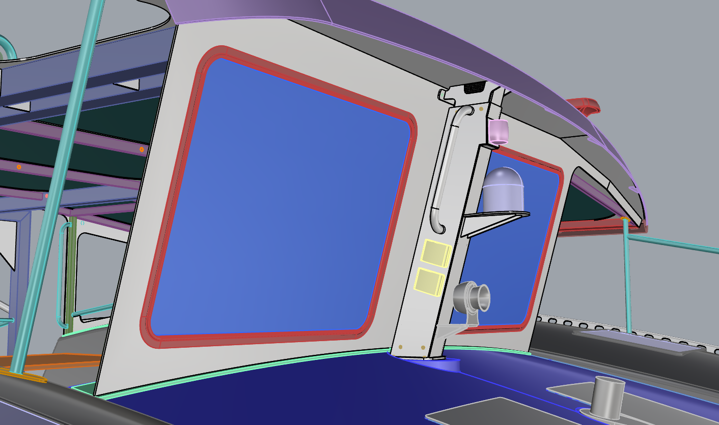
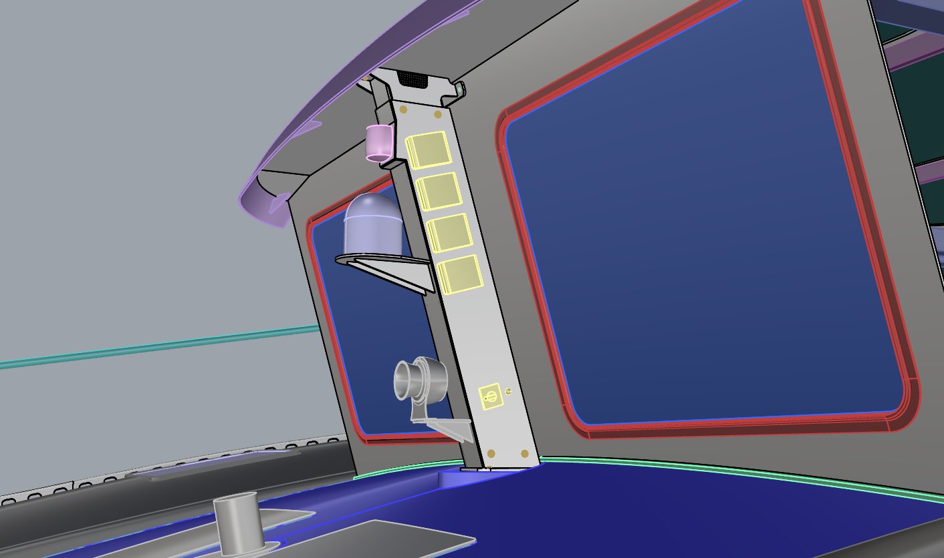

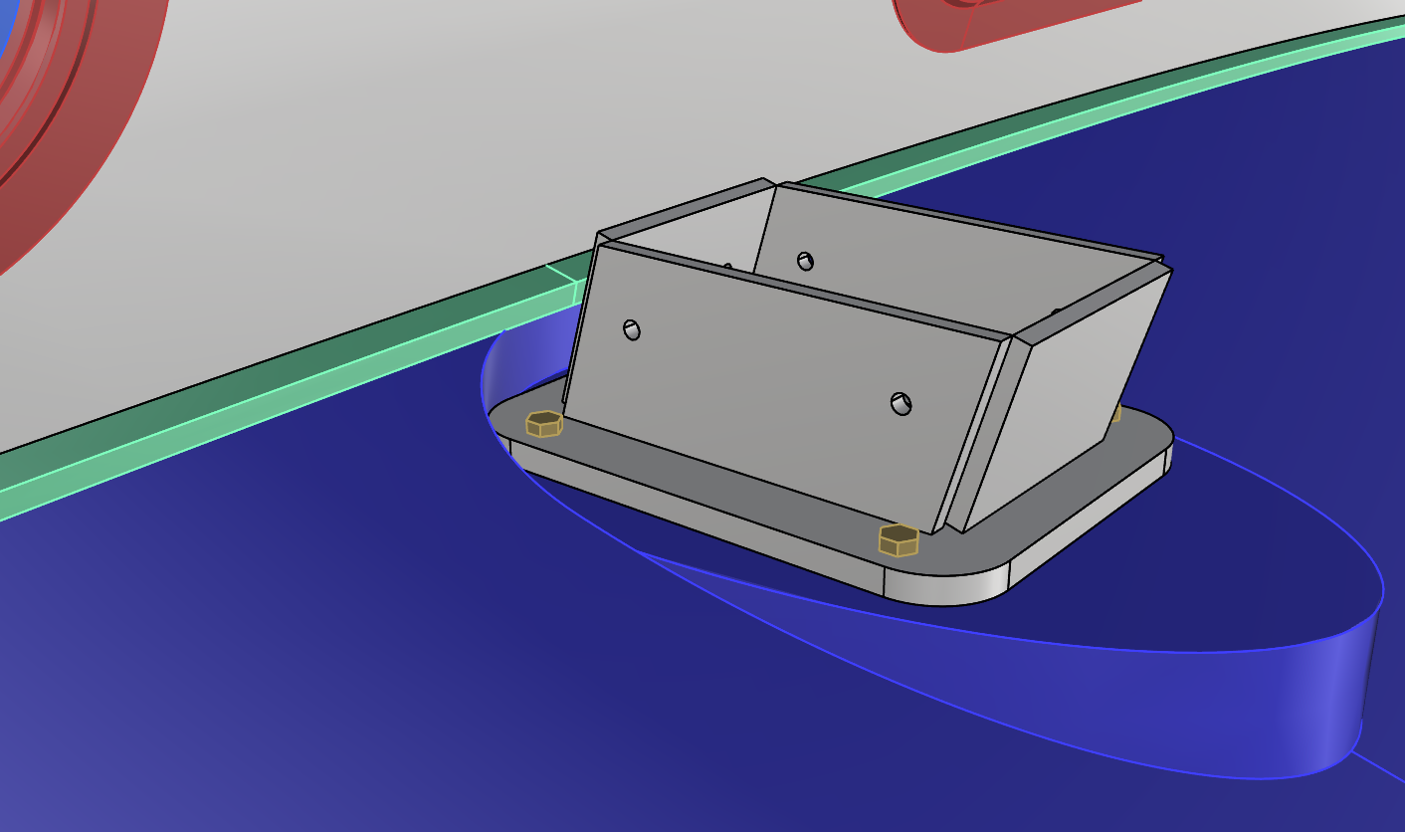
The removable mast body sits directly on the base flange at the bottom, and bolts or screws into an inner collar welded to the base.

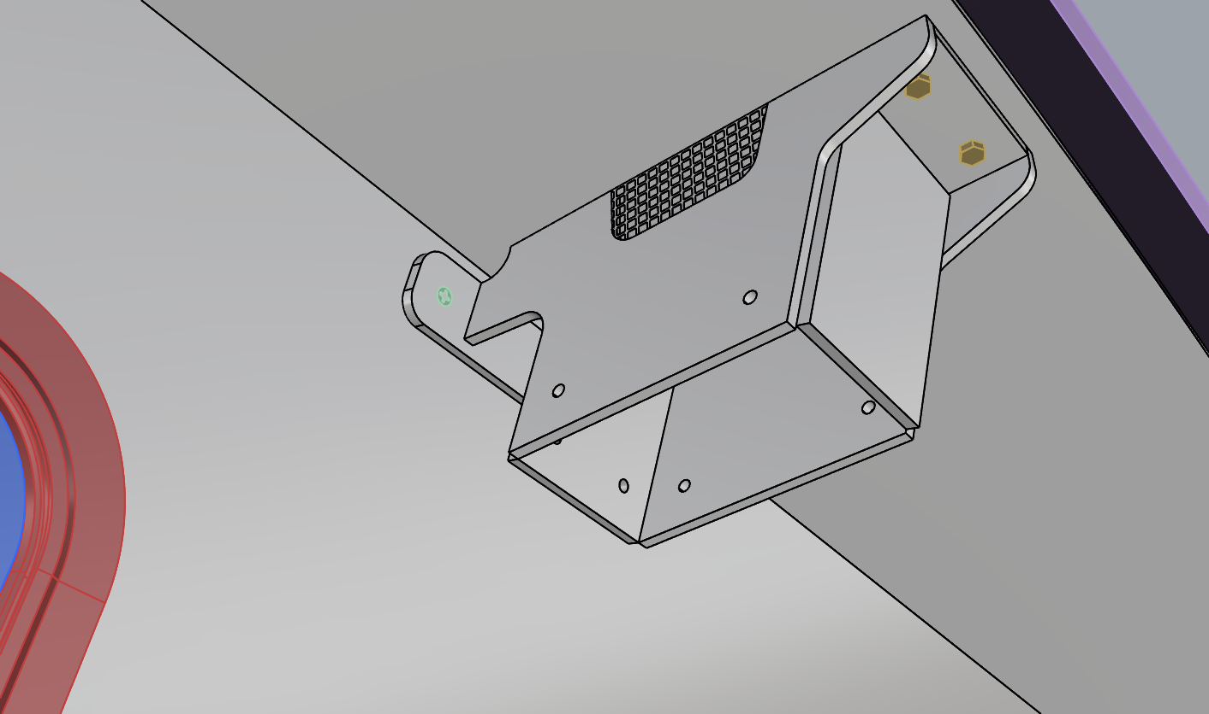
I initially didn’t like the idea of venting through the body of the mast, but the hot air is already in the battery compartment where all the inlet wiring ends up anyway so it may not be an issue. If there’s an opening for wiring the hot air will make its way up the mast anyway. The upper collar is a logical place for vents, being the highest point on the mast assemblage and reasonably protected from the elements by the existing canopy plate and brow fascia to be installed.

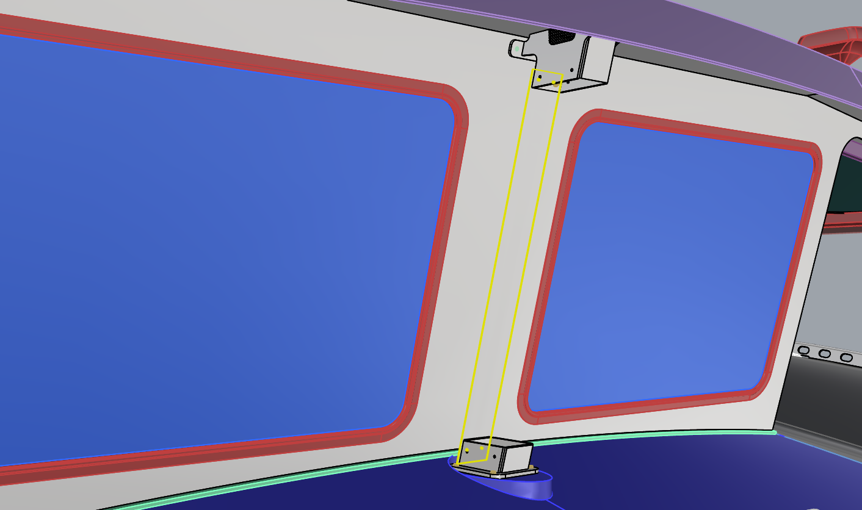
The backplate, separate from the main mast body, is just a rectangle. There might be some issues aligning or shooting holes for fasteners here, but nothing that cannot be solved with the right tools and planning I think.

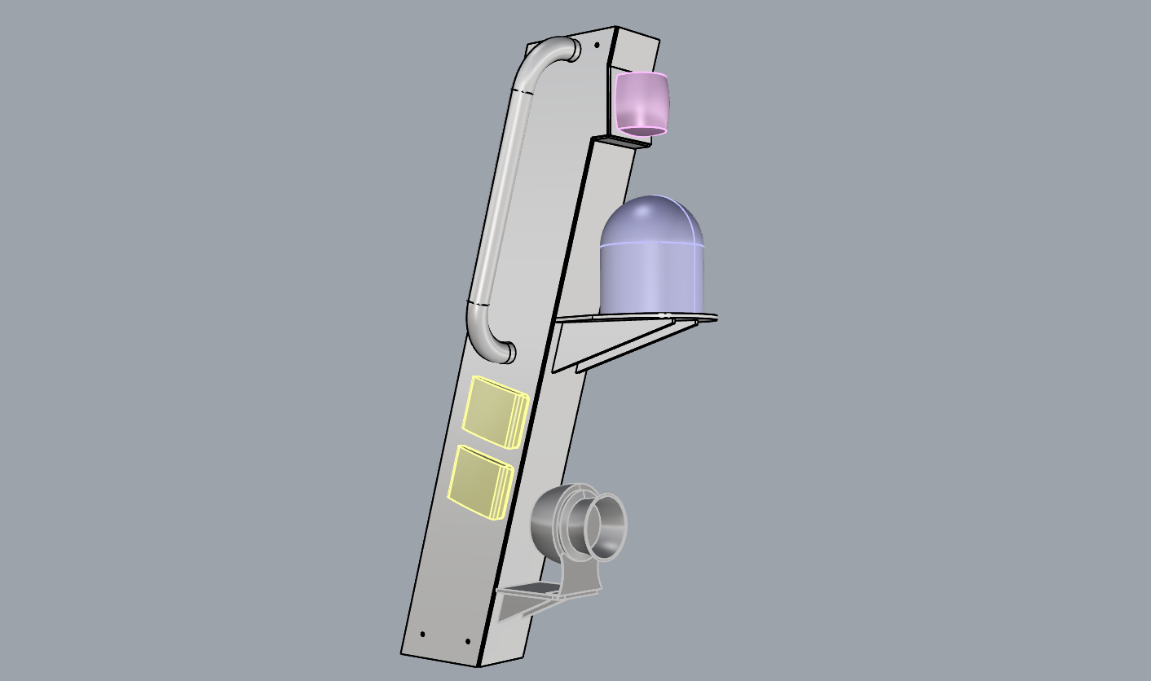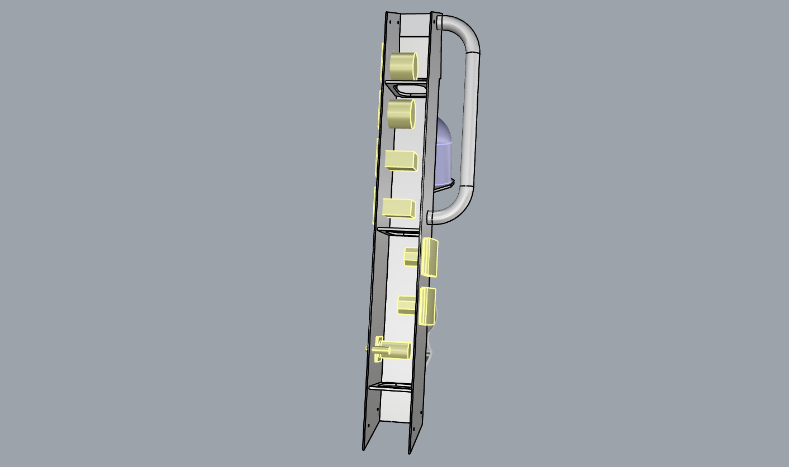
The main body of the mast: three major plates welded together corner-corner, with a vertical forward-facing facet up top as a mounting plate for the steaming light. Three ring frames help keep the plates rigid. Smartplug system components installed in port and starboard faces and offset from components on the opposite side; exact configuration of the components could be reviewed with EE folks or other experts for logic and ease of wiring. Grabrail on upper starboard face, and optional small platform for Marinco shorty or other horn near the bottom of the mast.

DB
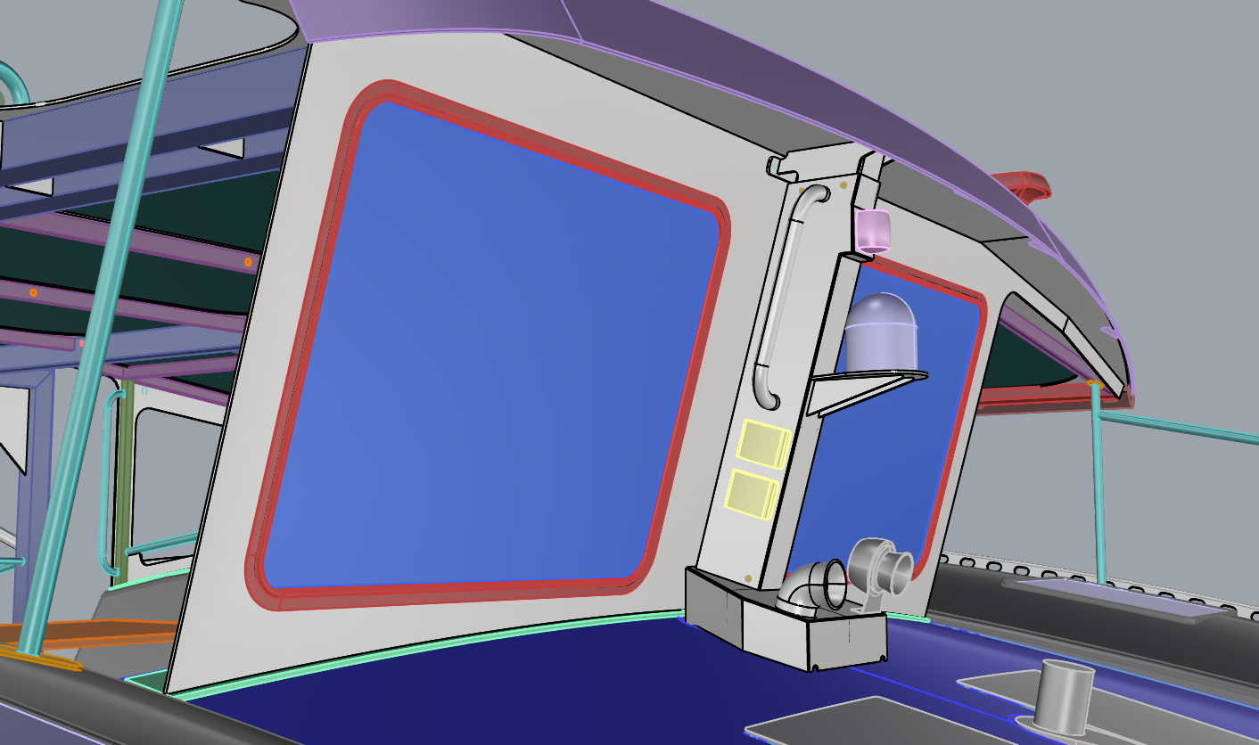
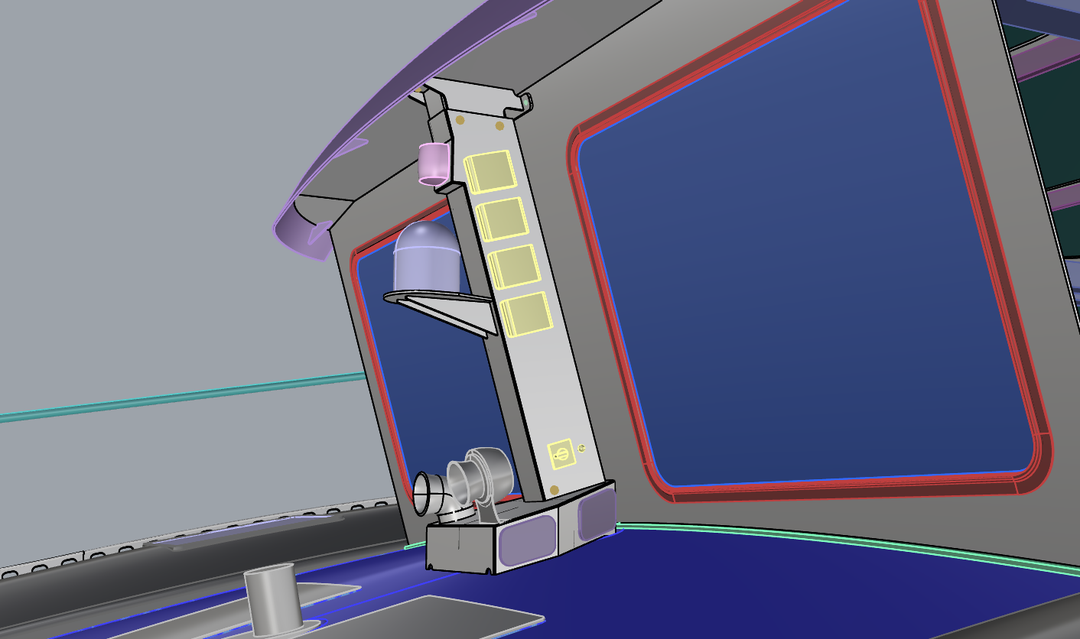
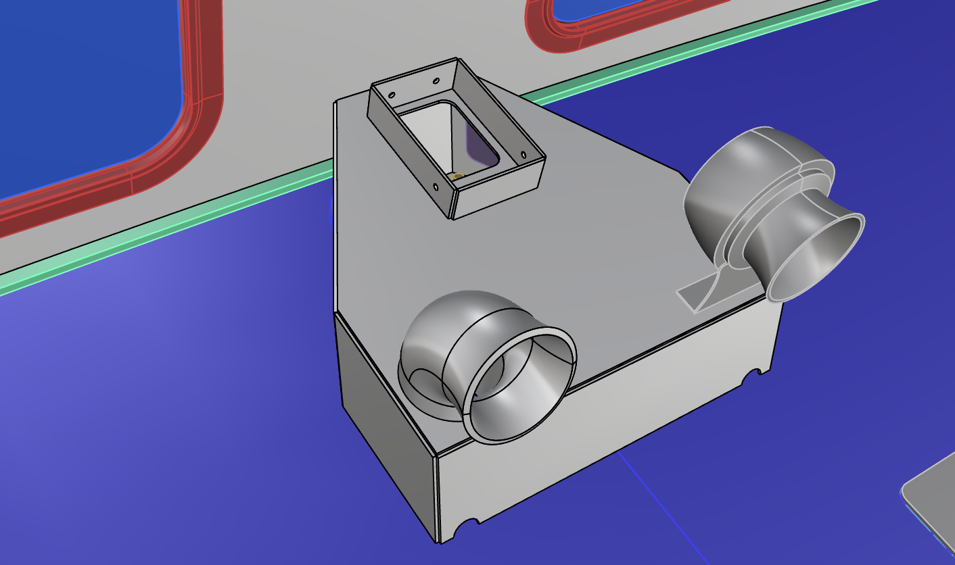
The removable mast body sits on the down-forward angled top of the box, and fastens to an inner collar welded to the top of the box. Since the mast body slides on this down-forward angle for installation and removal, it can be a little taller at the top and still clear below the brow fascia.

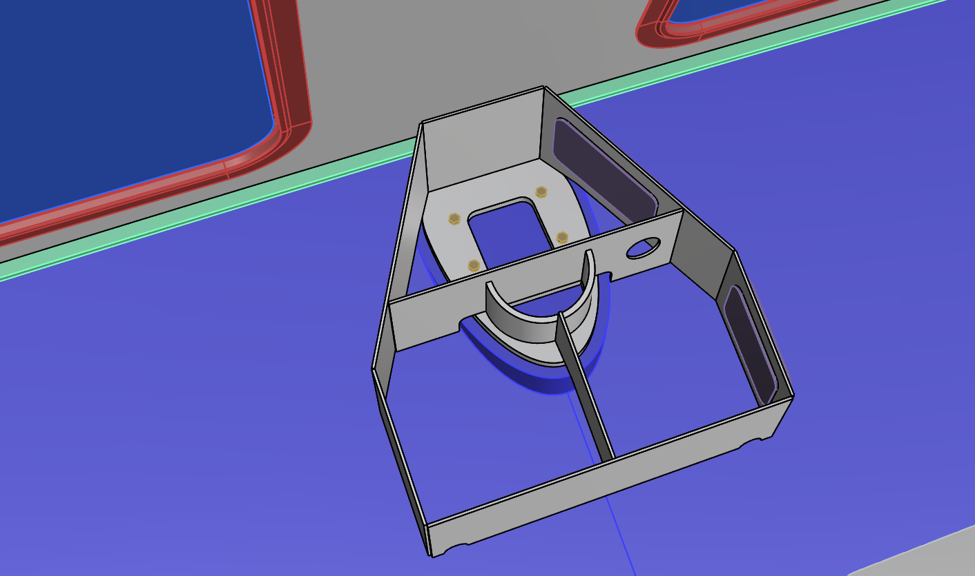
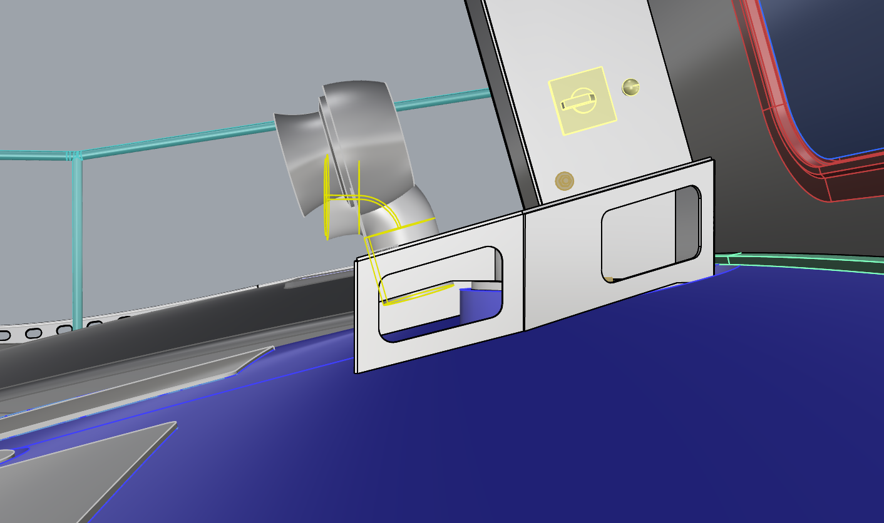
The interior of the box has gotten quite busy!
- Transverse ‘bulkhead’ to mostly separate the aft wiring area and the forward venting area, long’l frame for rigidity forward, half of a SCH40 4” nominal pipe for a lip around the vent opening per a dorade box.
- Separate openings for wiring and for ventilation, which would make more sense if there’s something functionally like a cable clam or gland at the wiring opening, because the hot air won’t know which door to take on its own.
- Little ‘plug hatches’ of HDPE or similar to port, for access to tighten flange bolts and to run wiring from shorty horn aft and down.
- The aft face, small parts of the diagonal side faces, and parts of the framing plates can be welded to the egg-shaped bolting flange, but the majority of the box’s footprint is right on the curved center beam console surface or possibly cantilevered a fraction of an inch above it. I don’t like aluminum plate edges right on painted composite, and I don’t like building a full slightly curved baseplate for the box’s footprint. A gasket of some attractive material and/or a 5200 fillet around the outside could be a solution.
- Replace or bend the shorty horn’s mounting flange to get it pointed directly forward.

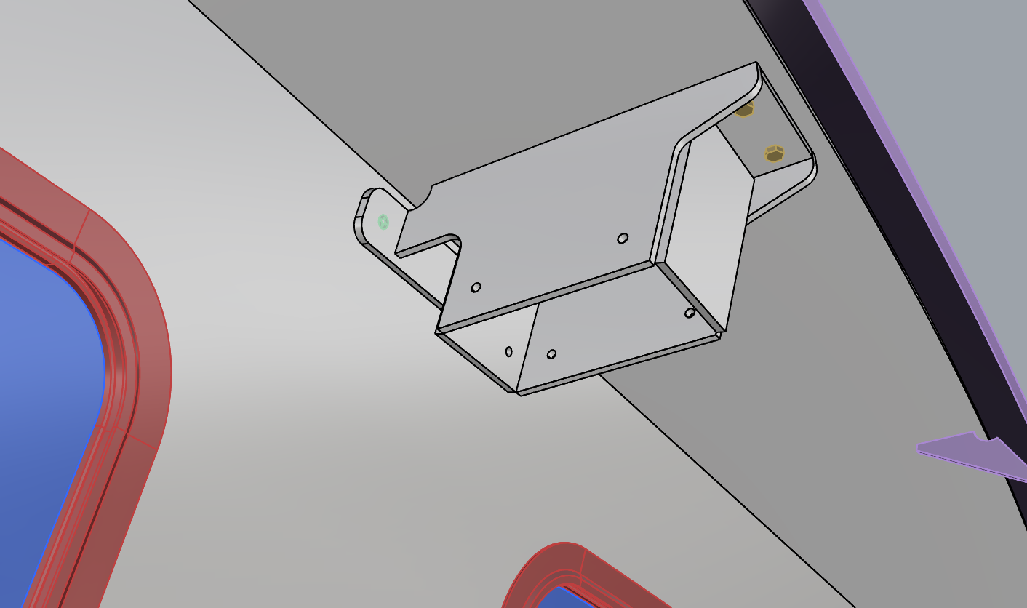
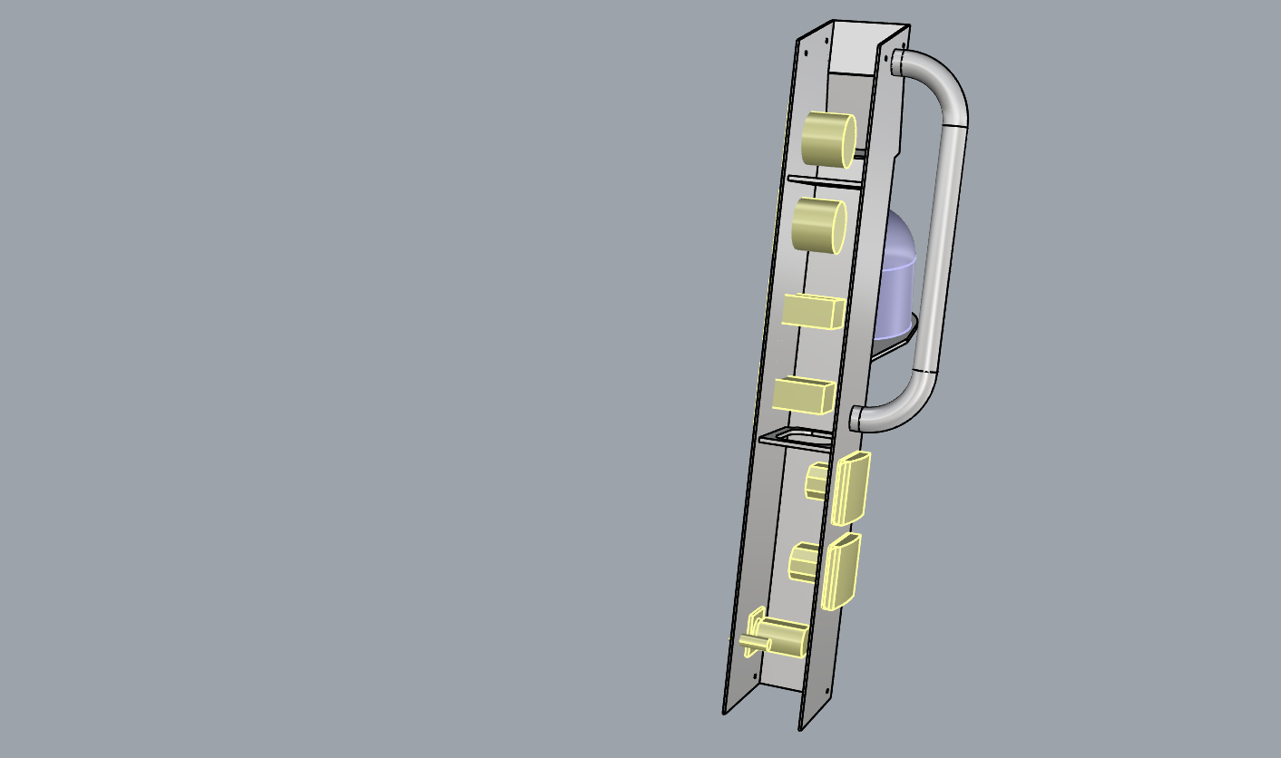
The removable main body of the DB version follows the same logic and geometry as the V4 version, except that it’s shorter overall but extends ½” higher at the top. Upper collar can be ½” shorter, and won’t need vents if we vent at the dorade box below.

Operative questions V1-V4
- Is it worth pursuing a deliberate separation between wireways and ventilation? If not, do we like the dorade box enough to keep the design and build it anyway?
- Is the premise of the removable mast body sound? Will it avoid more headaches than it creates for the people building the parts and the people installing and wiring the inlets and instruments?

22 APR 2026
I’ve modeled several more versions (V5-V9) aiming to simplify or eliminate the collar-style joints and explore other dorade box-style ventilation arrangements.

V5 - FRP DORADE BOX
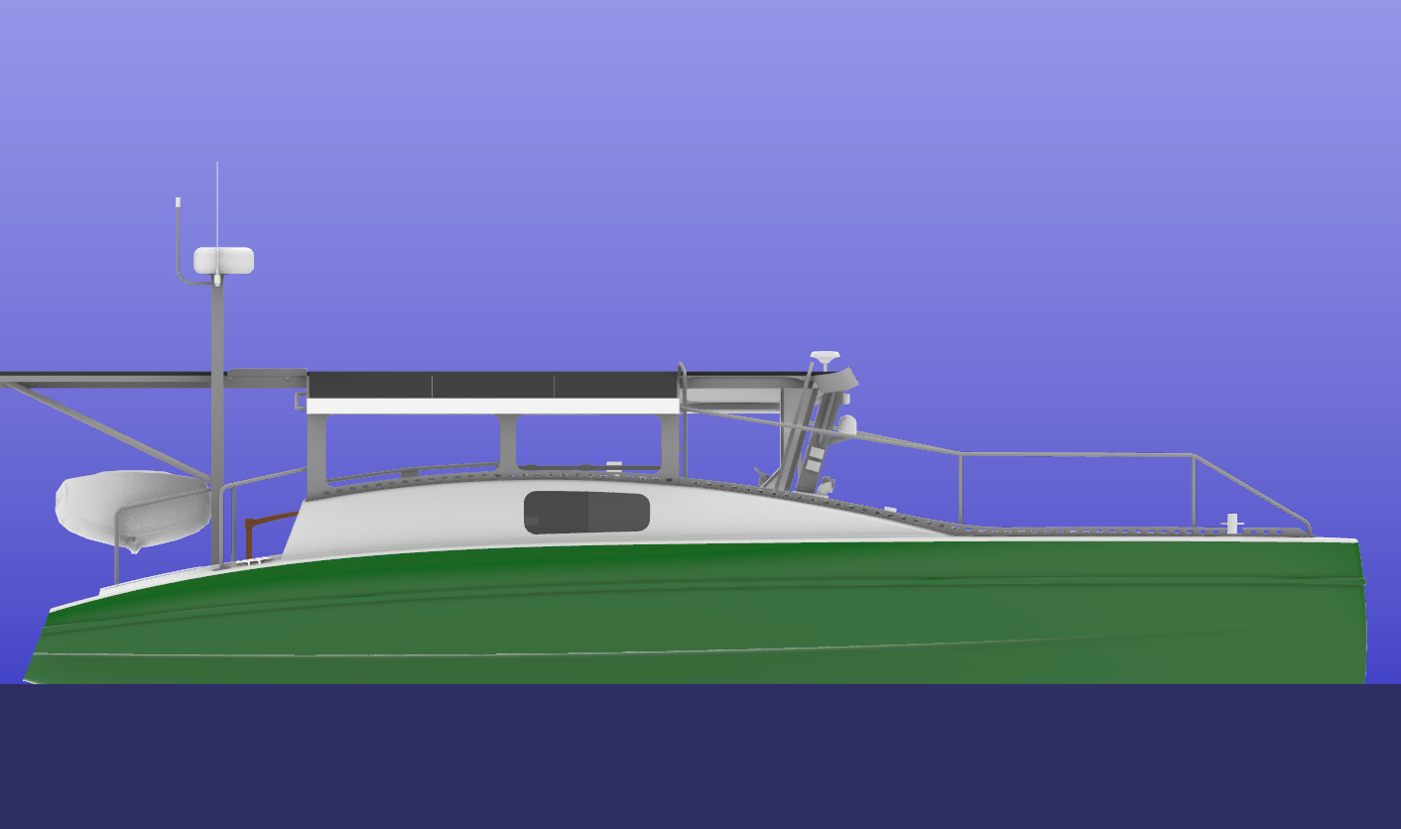
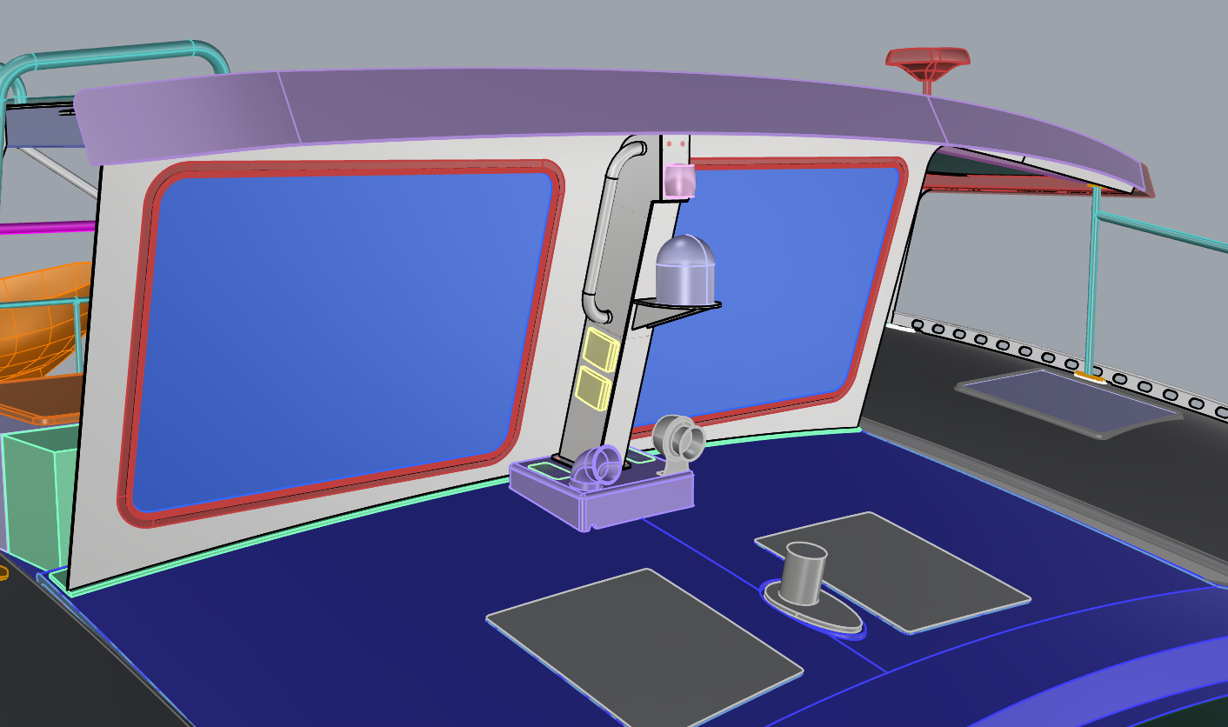
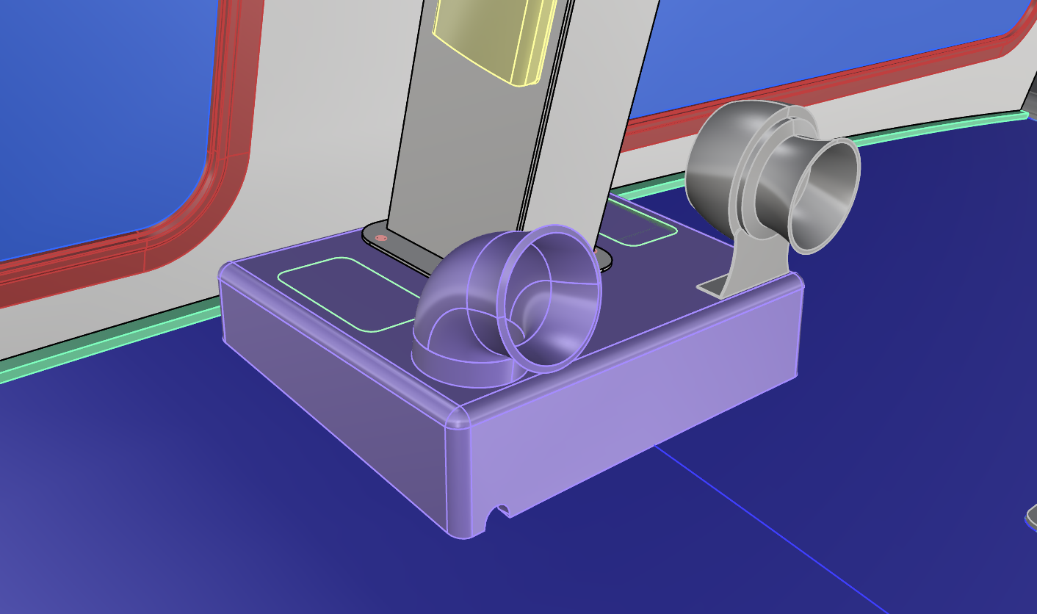
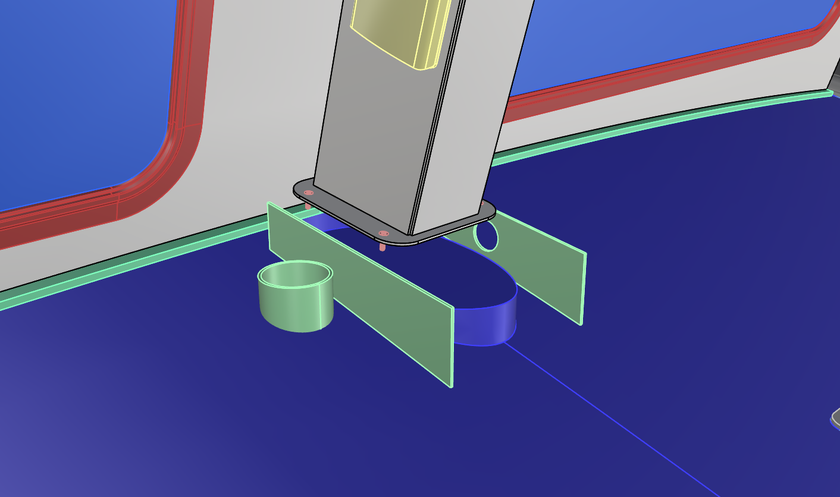
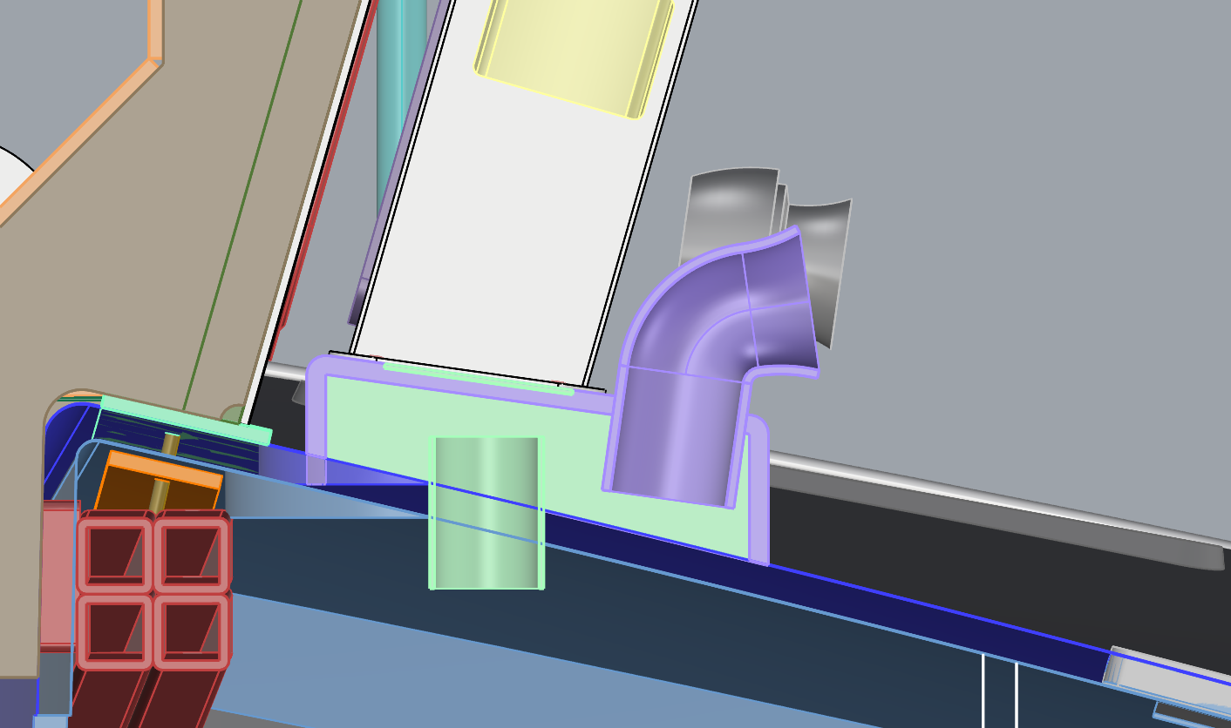
- FRP dorade box that would be permanently attached with epoxy/adhesive fillets and possibly FRP tabbing to the deck/console surface forward of the existing windscreen and over the mast pedestal flat
  - G10 (or similar) long’l frames/dividers separate the stbd dorade ventilation area from the rest; horn wiring can run through the port long’l frame and into the battery compartment
  - Optional removable panels on top of the dorade box

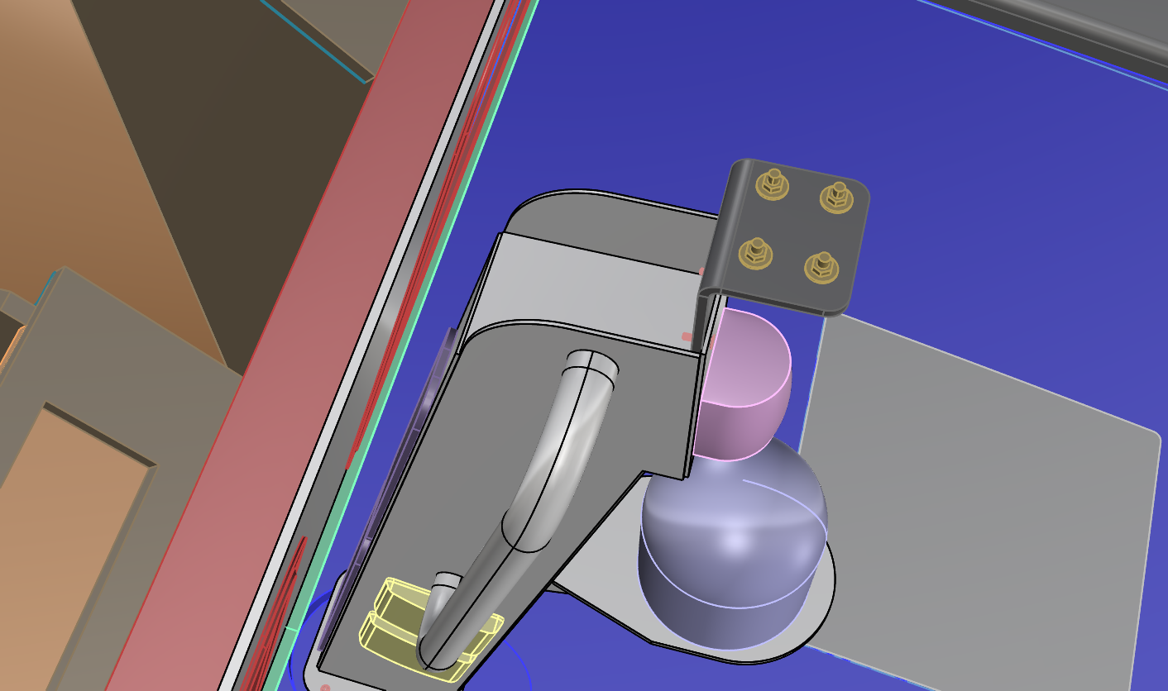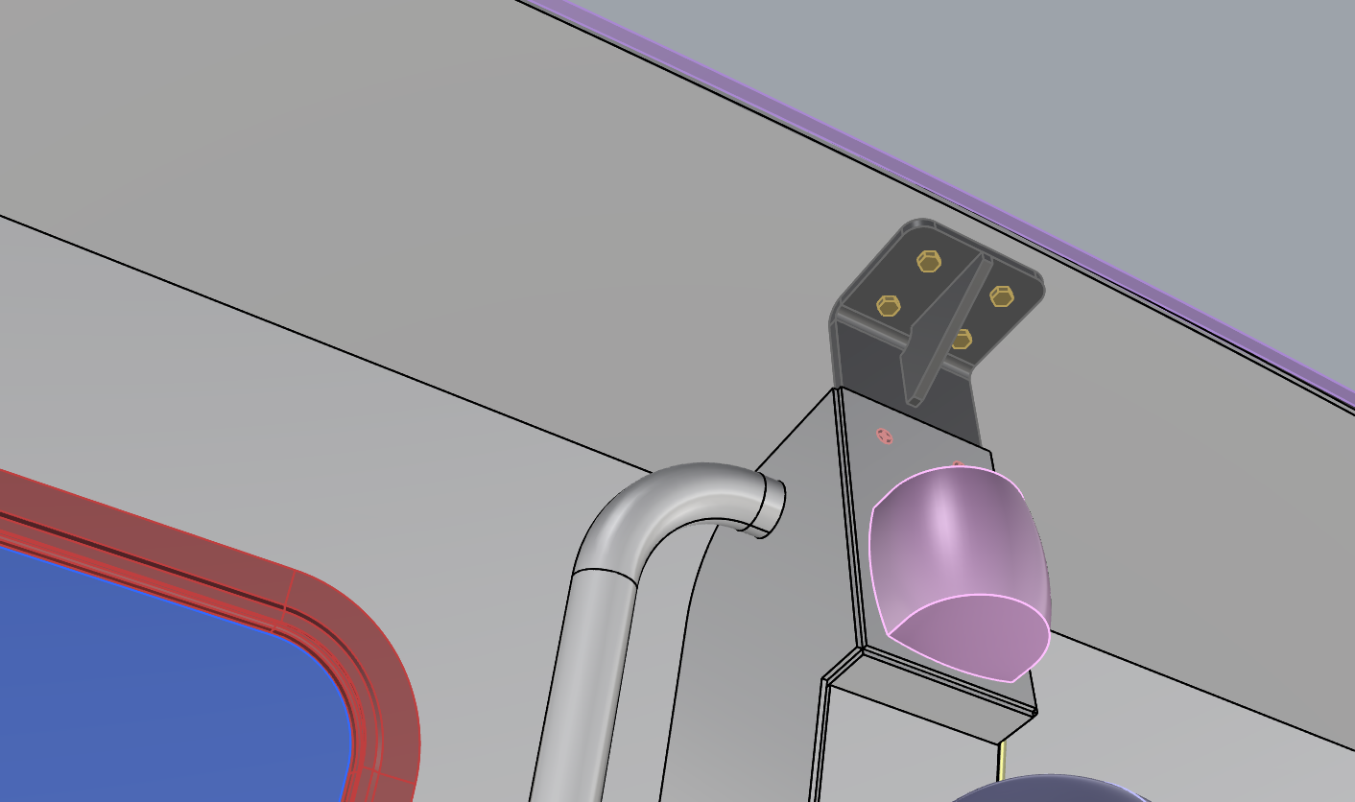
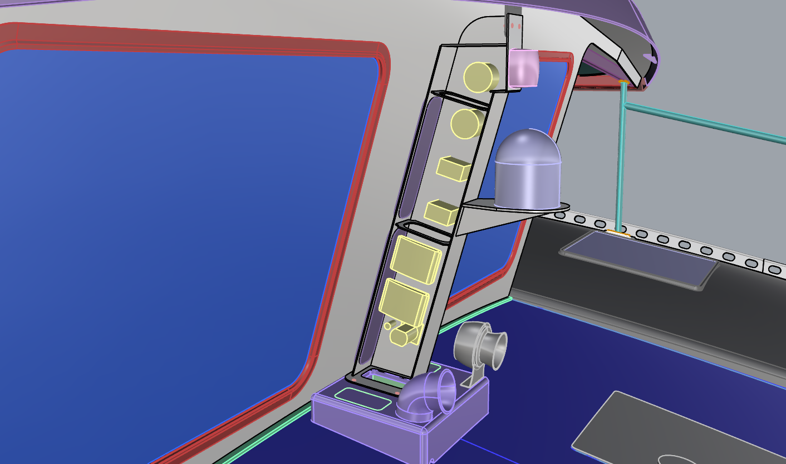
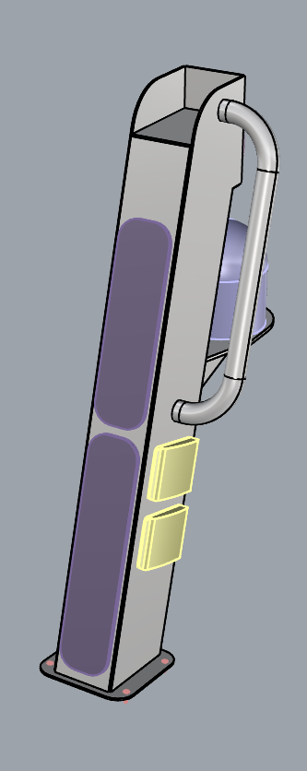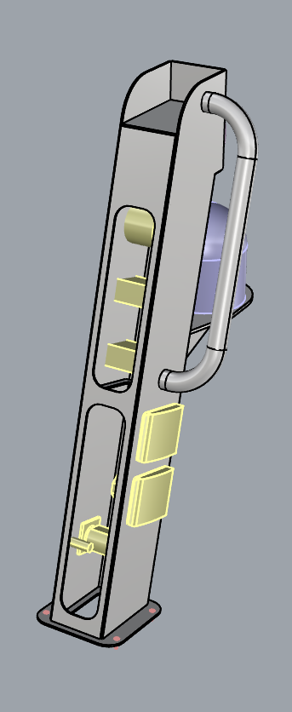
- Rectangular section mast, similar to previous versions but enclosed at the top and back
  - Lower flange fastens to top of FRP dorade box, ideally with threaded inserts laminated into the top of the dorade box or similar
  - Upper flange fastens to L-bracket bolted to overhanging canopy
  - Cut-outs with HDPE plug-hatches on aft face of mast for initial wiring off the boat and for limited access after mast installation on the boat
    - We could locate another access cut-out on the lower forward face of the mast but it’d be much more visible and ‘hanging’ at a 16 degree angle so it would need a good seal and latches/fasteners
  - The entire mast is still semi-removable depending on the fasteners and sealant or gasket at the lower flange.

V6/V7 - OFF-THE-SHELF DORADE COWL OFFSET FROM MAST
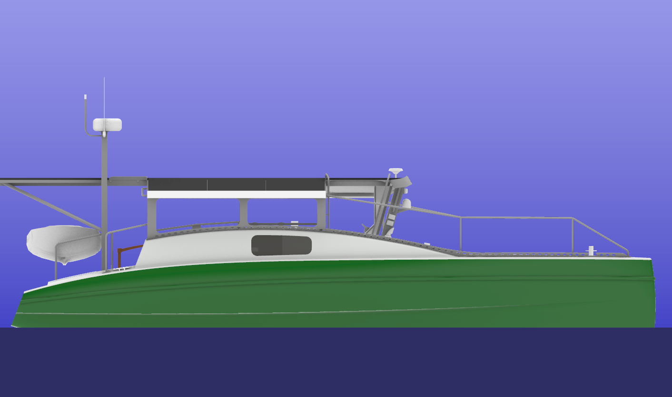
V6^
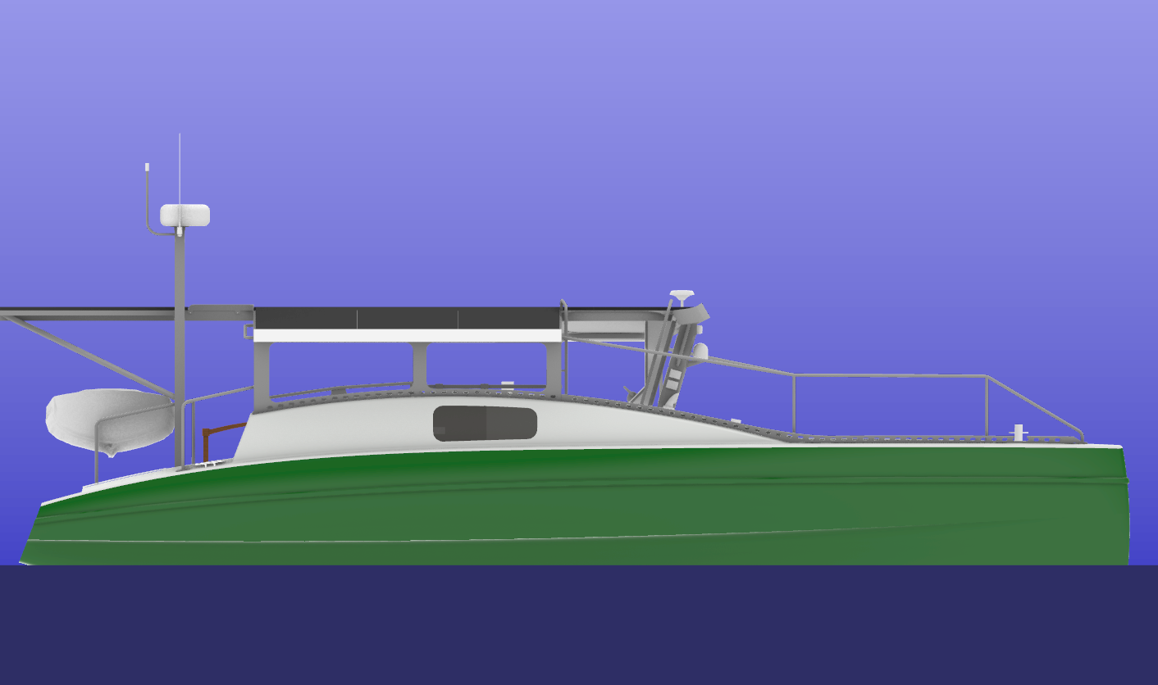
V7^
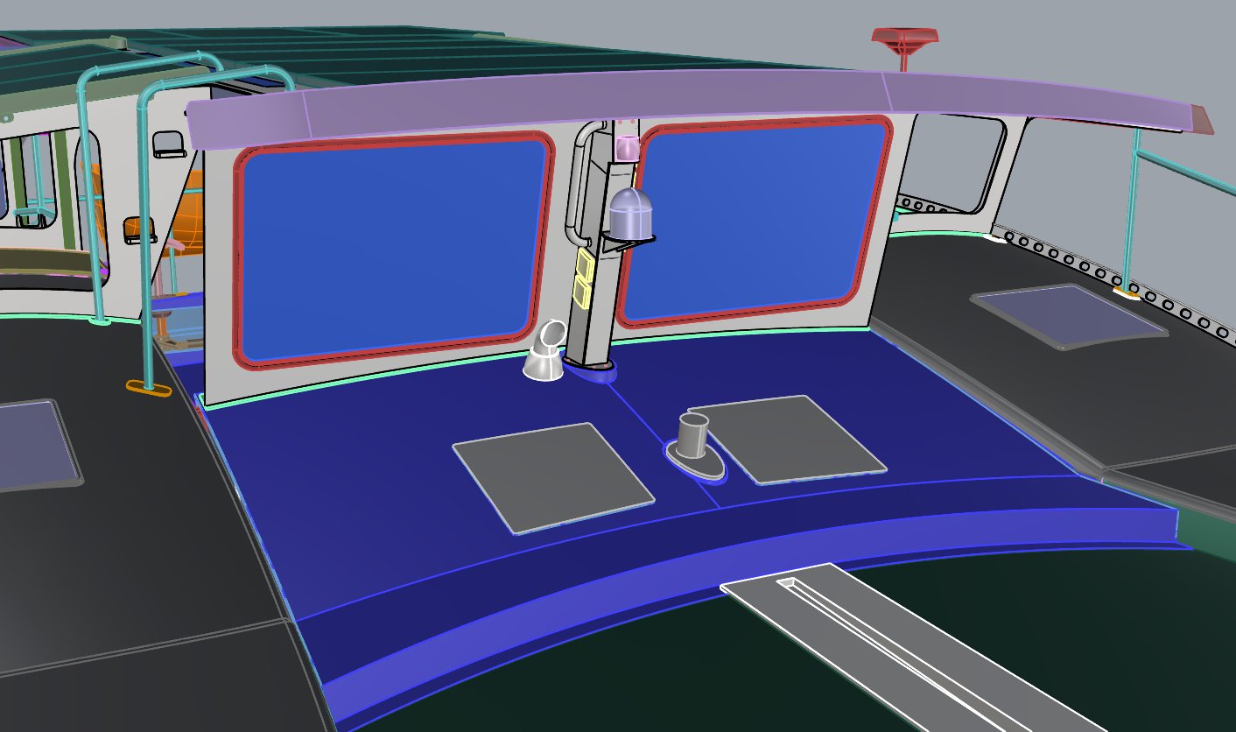
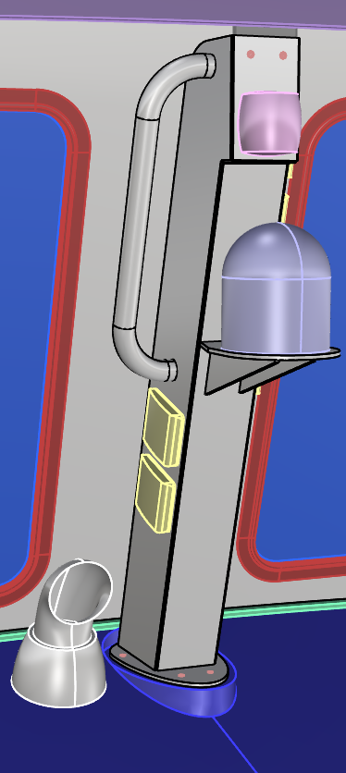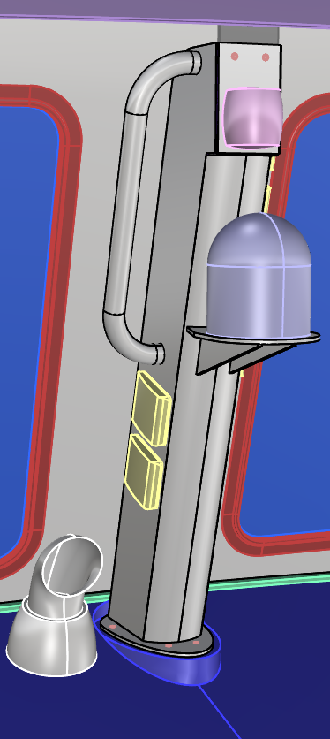
- Vetus dorade cowl SKU BOXS75 shown in model, offset to stbd to allow for slide-in mast installation, set forward enough to allow for maintenance/removal of windscreen framing.
- V6 mast (above left) has a flat ⅛” aluminum plate for its forward face, V7 mast (above right) has a portion of a 5” nominal SCH40 pipe for its forward face.
- Egg-shaped lower flange could fasten to threaded inserts bedded in sandwich laminate of existing mast pedestal; access to other side for hex nuts will be limited once batteries are installed and mast wiring is in place.
- Upper flange and other mast features are the same as V5.

V8 - CUSTOM ALUM. DORADE BOX IN-LINE W/ MAST, OFF-SHELF COWL
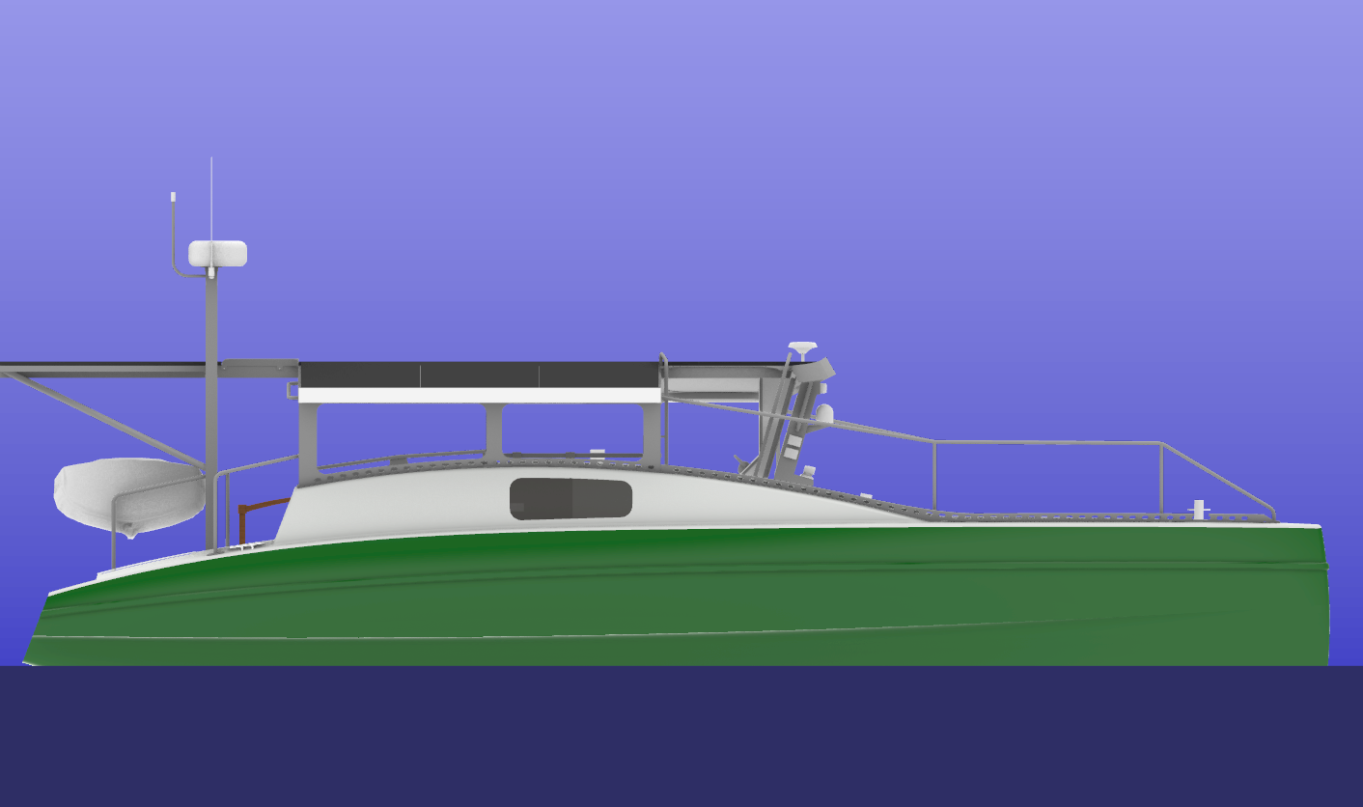
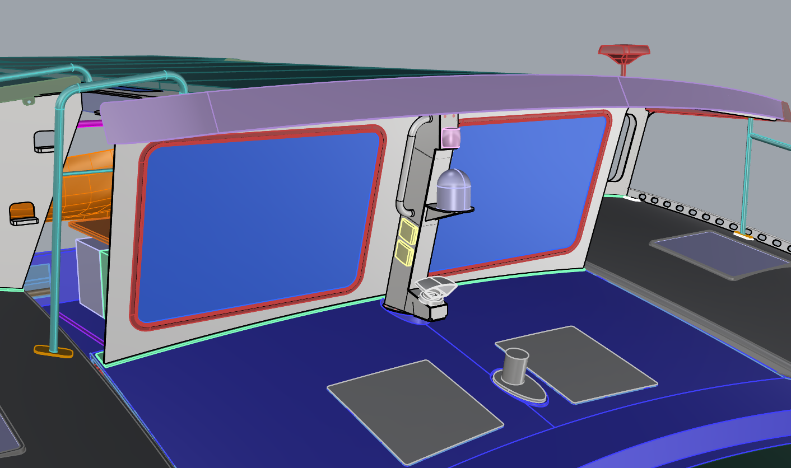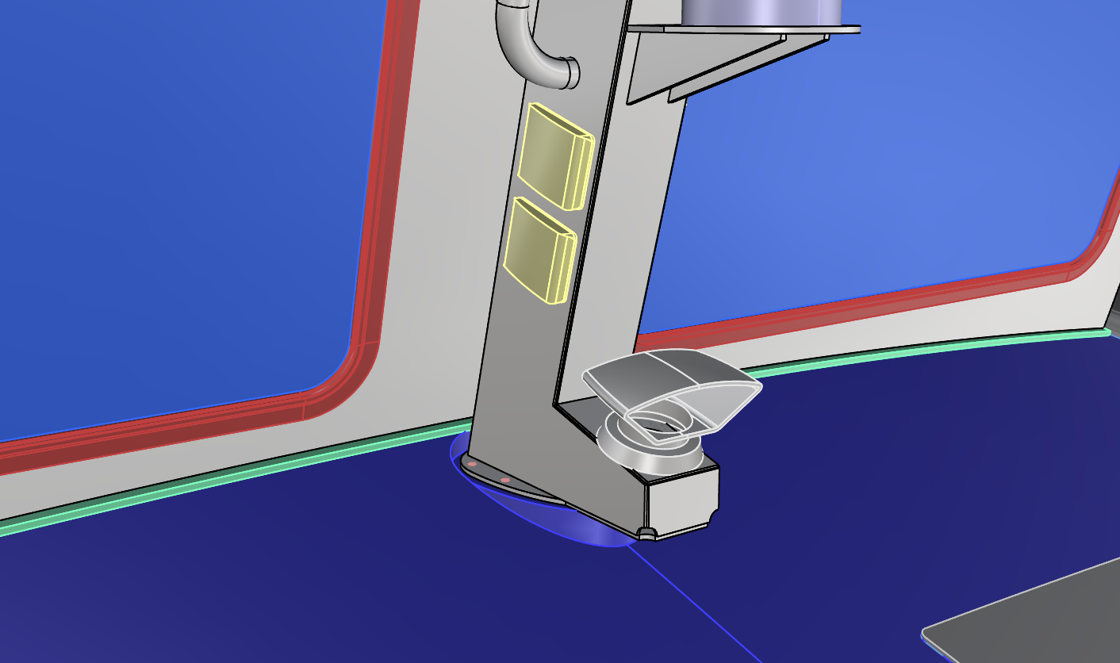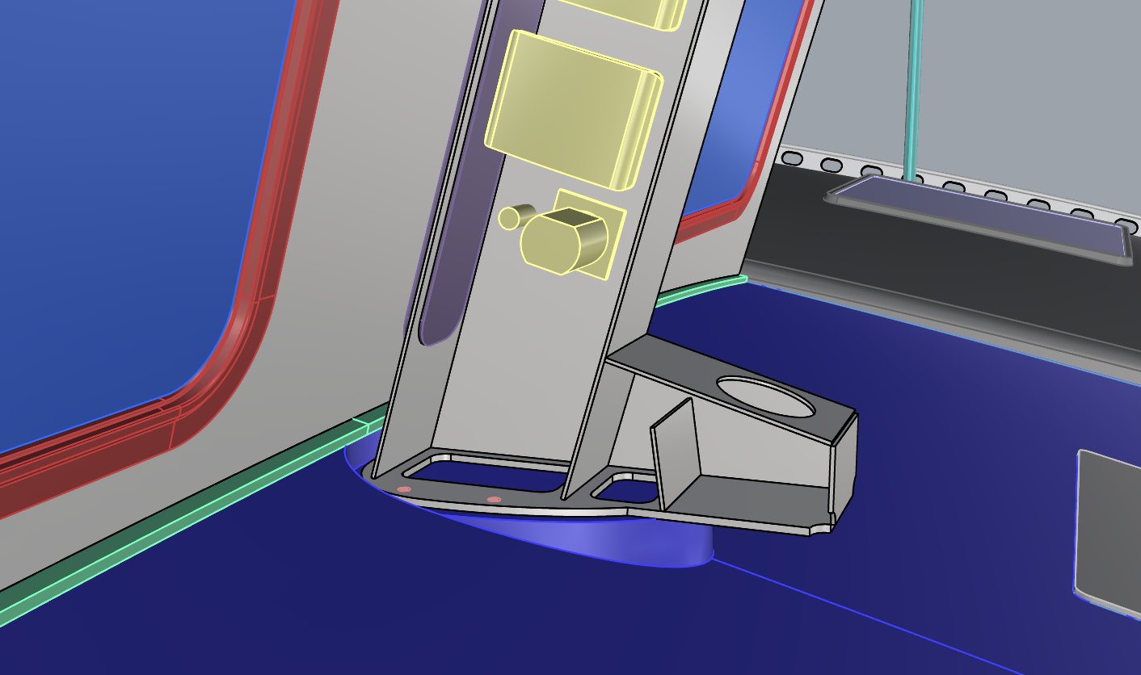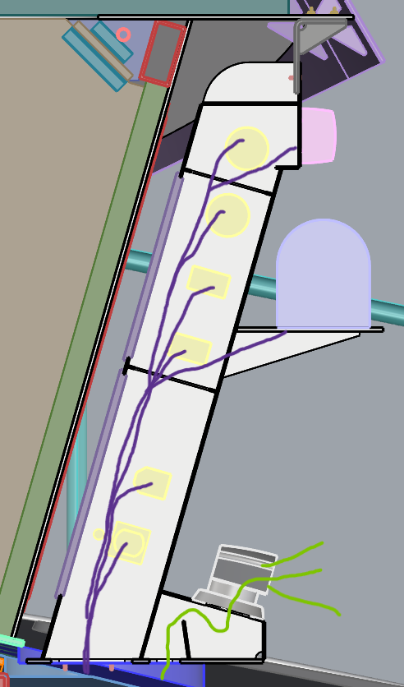
- Dorade box built into semi-removable mast body, forming a ‘foot’ that hangs past the forward edge of the existing mast pedestal
  - Dorade box fully separated from internal mast wiring by mast forward face that extends down to lower flange.
  - Fastened with screws & threaded inserts in pedestal like V6/V7
  - Vetus Tramon cowl shown
    - This specific cowl has 7 square inches free flow area; I’ve allowed for 6 square inches at all ‘chokepoints’ (opening into the battery compartment and space above the dorade baffle).
  - The dorade baffle plate will be completely enclosed by the faces of the finished mast/dorade box component, so it may need flanges against one or more of those faces to allow for plug welding.
  - I believe the forward-sloping top face of the dorade box will help prevent condensation from entering the battery compartment, with water droplets sliding forward to the drainage area.
- Mast geometry and upper flange are the same as V5, V6, V7.

V9 - CUSTOM ALUM. DORADE BOX IN-LINE W/ MAST, CUSTOM/INTEGRATED COWL

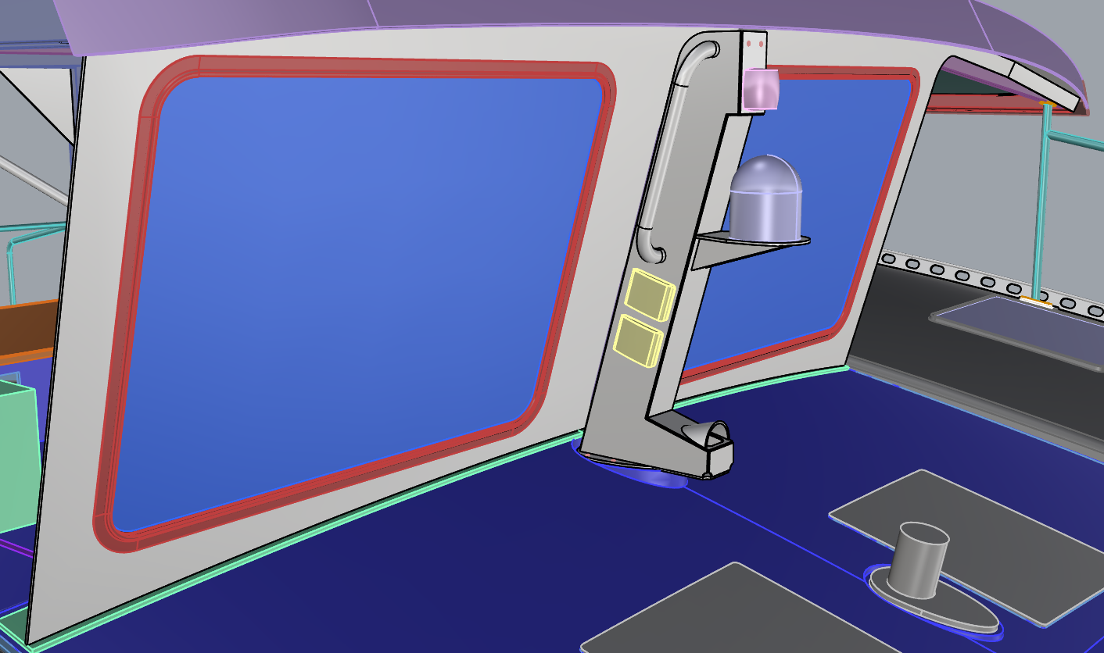
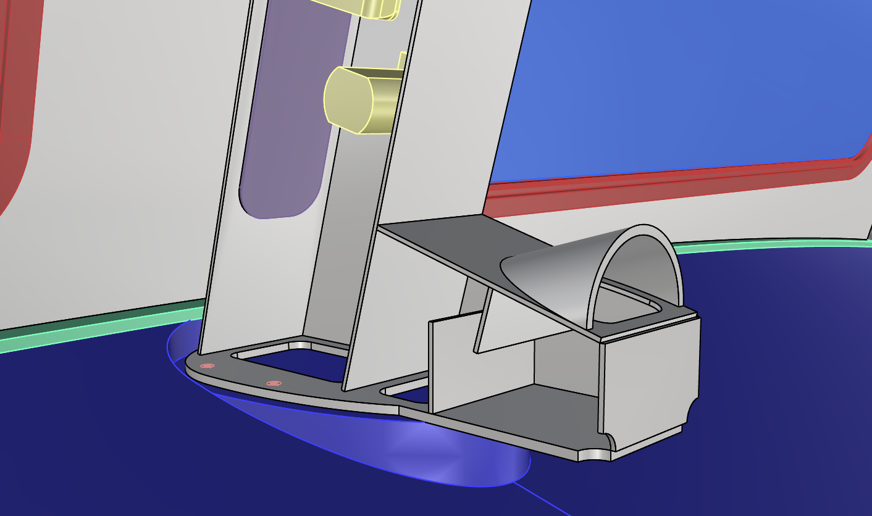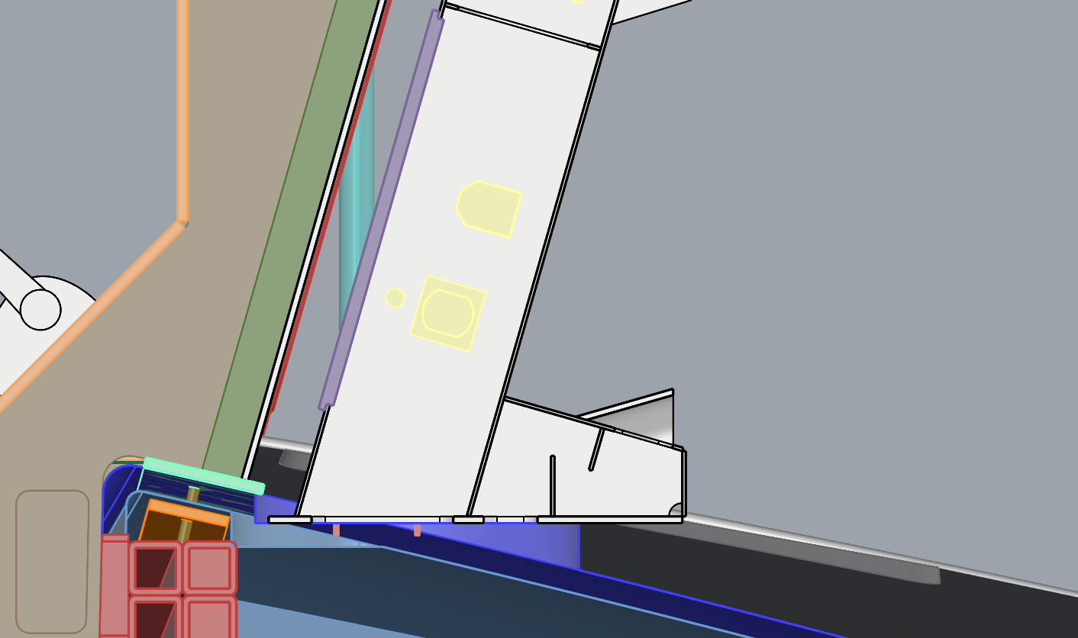
- All parts are the same as V8 but with a segment of nominal 3 ½” SCH40 pipe as the cowl instead of an off-shelf part.
  - Free flow area is 5 square inches minimum
- If we want to fabricate a fully custom dorade box/cowl assembly, it’s a chance to give it some style like the grill of a hot rod car. This model is pretty simple but we could get wild with it and show off if we so chose.

Operative questions and thoughts V5-V9
- Is there a target ventilation free flow area for this compartment and these batteries in particular?
- Is it practical to aim for a mast flange, screws & threaded inserts bedded in the existing mast pedestal as the main fastening joint for the mast?
  - I’d want a careful ship check of the ‘footprint’ area and the angle of the mast pedestal before locking in part details especially if aluminum sheets are to be CNC’d. Maybe an exploratory core sample of the laminate from a hole saw cut, where we’ll eventually cut a larger opening for wireway passage or ventilation.
- Is the limited access to the interior of the installed mast acceptable?

23 APR 2026

Notes & thoughts
- If we have a dorade box at the mast foot, what can we do to ensure that hot air is routed to vent through there rather than hot air/gas buildup in the mast body? Do we still want a very small vent near the top of the mast body, maybe tucked into the upper aft face?
- Will we have the tools to form/bend any of the aluminum? In some cases a radiused edge would be prettier and more functional than a continuous corner-corner weld.

27 APR 2026

V10-1 – V10-9: Alum. dorade box styling study
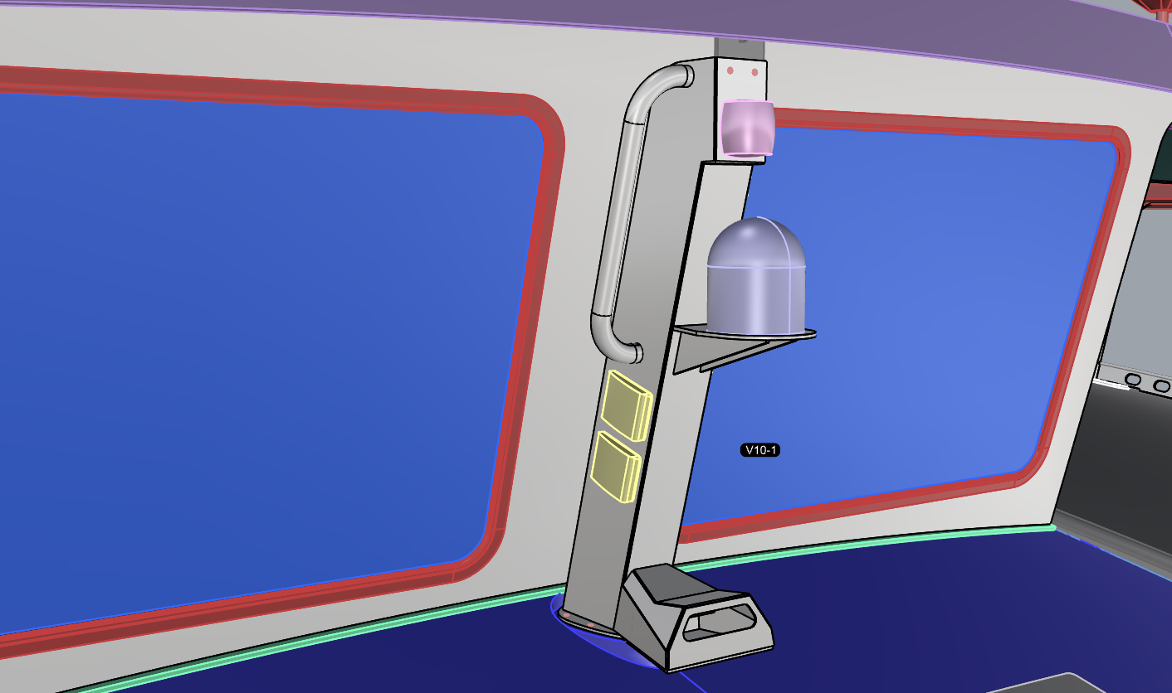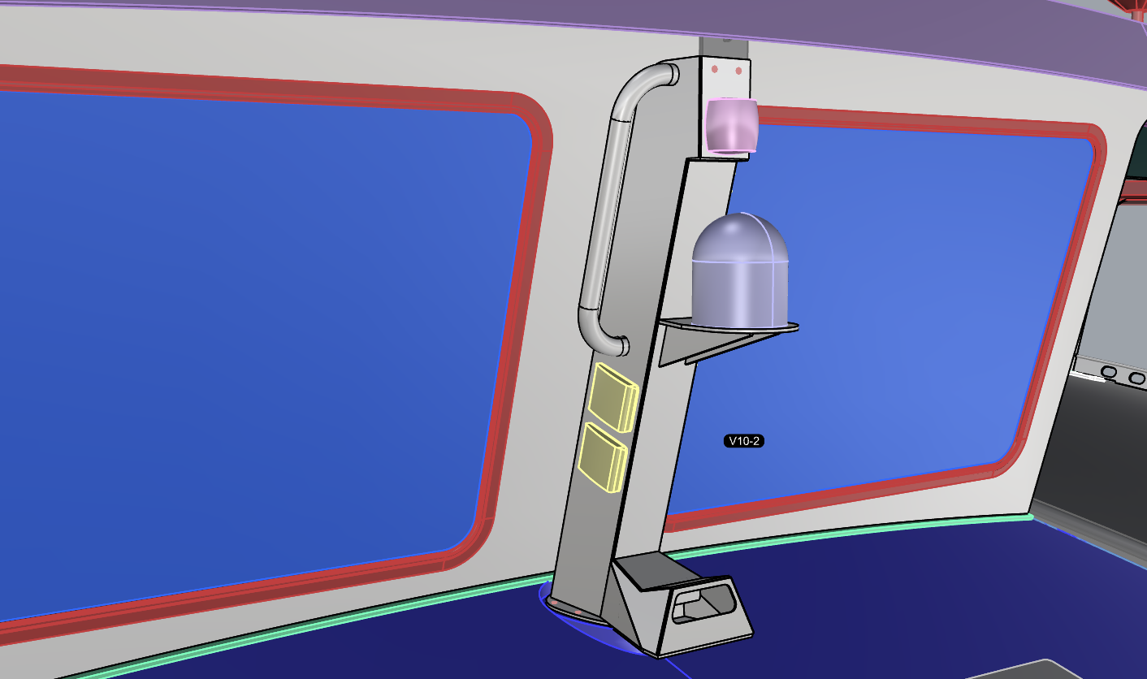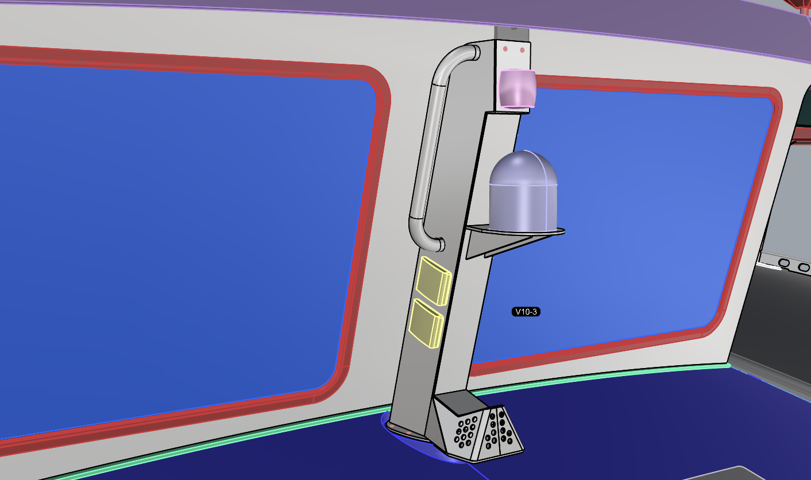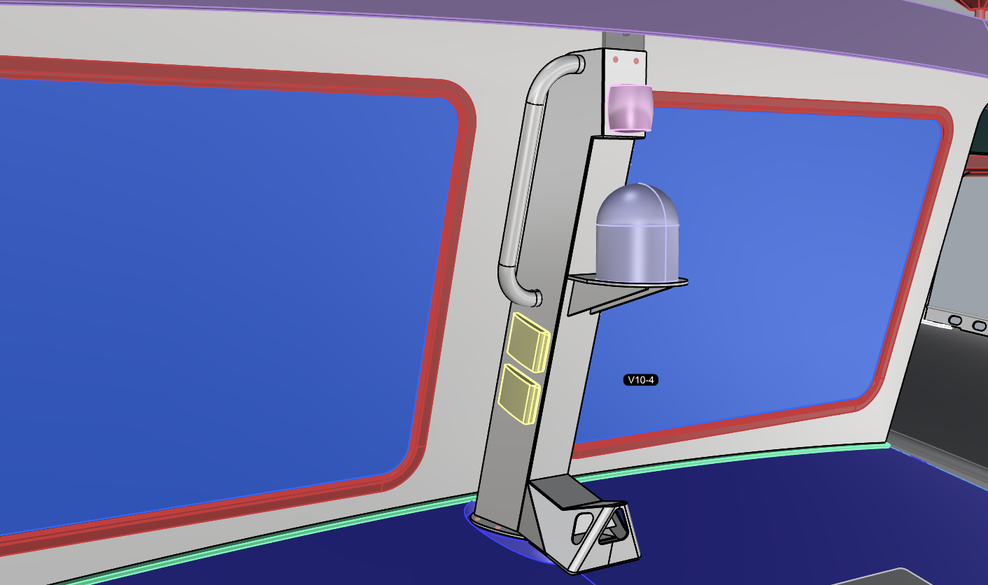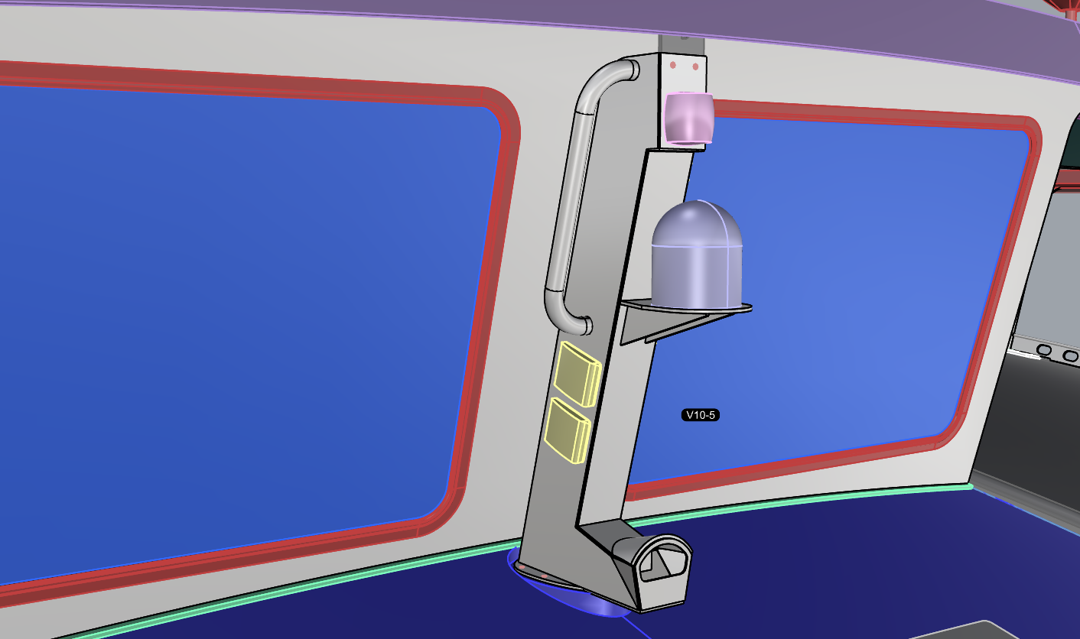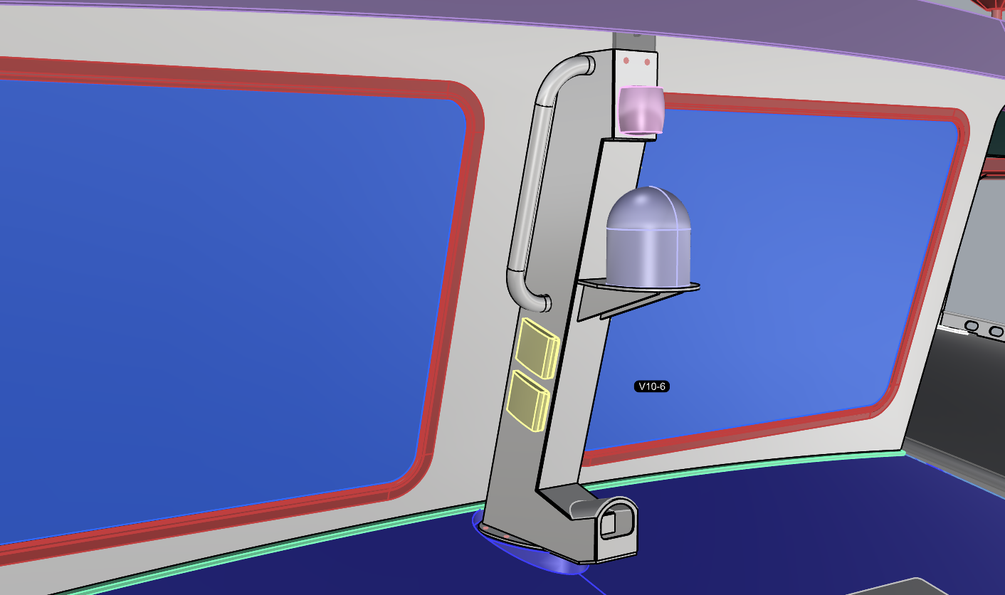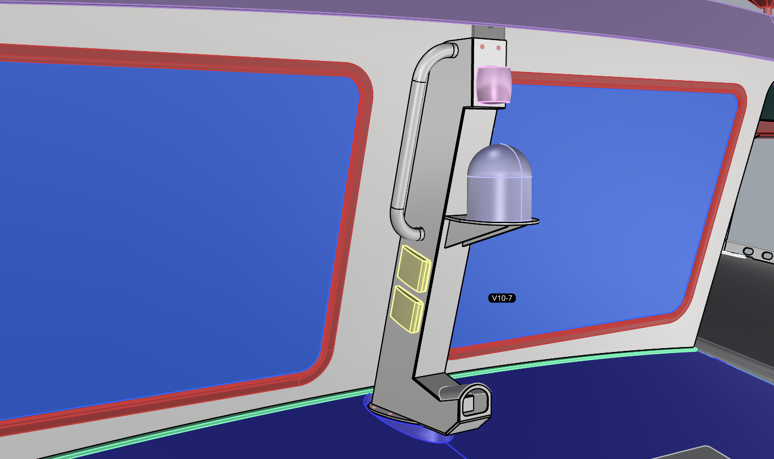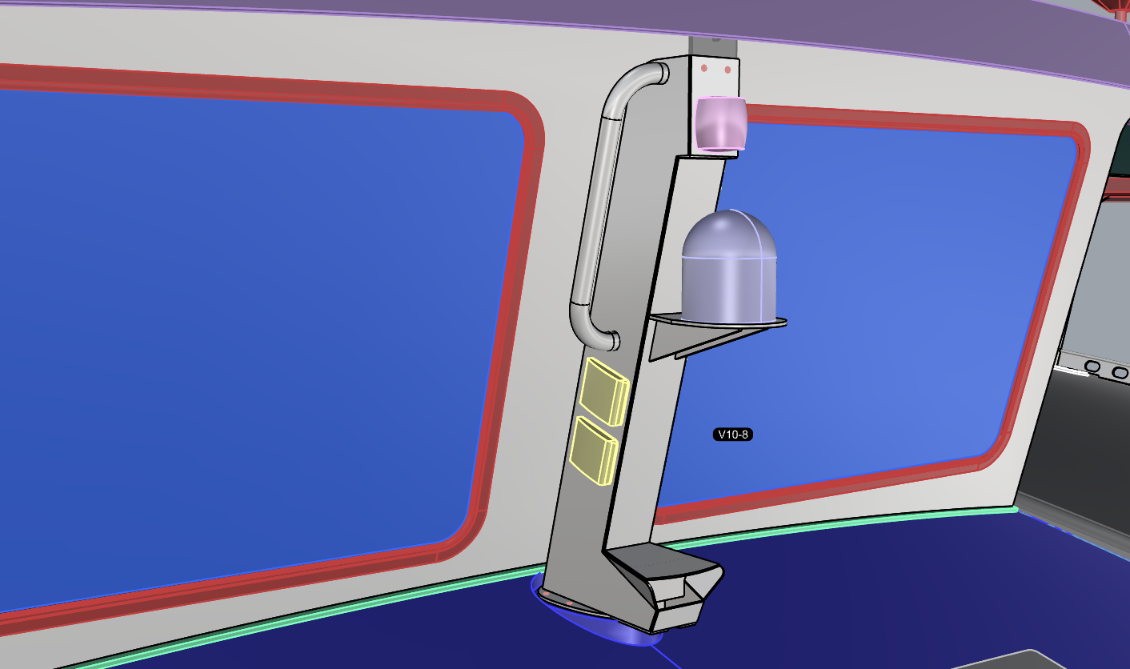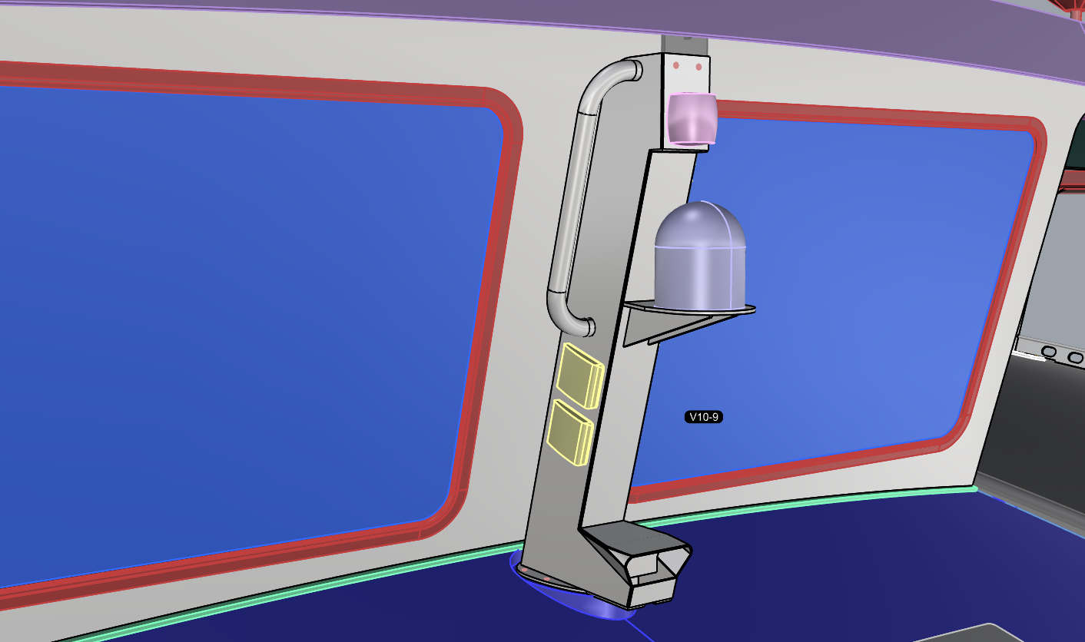
- Nine different dorade box-foot-cowl-intake styles – I like the last (V10-9) the best.

V10-9 more views
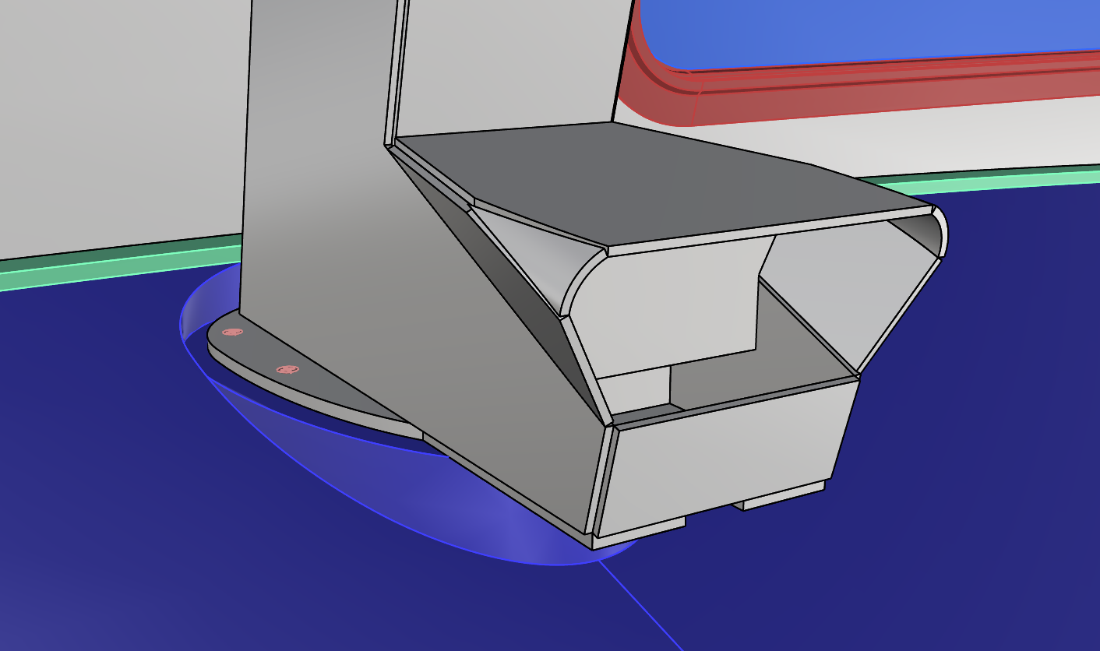
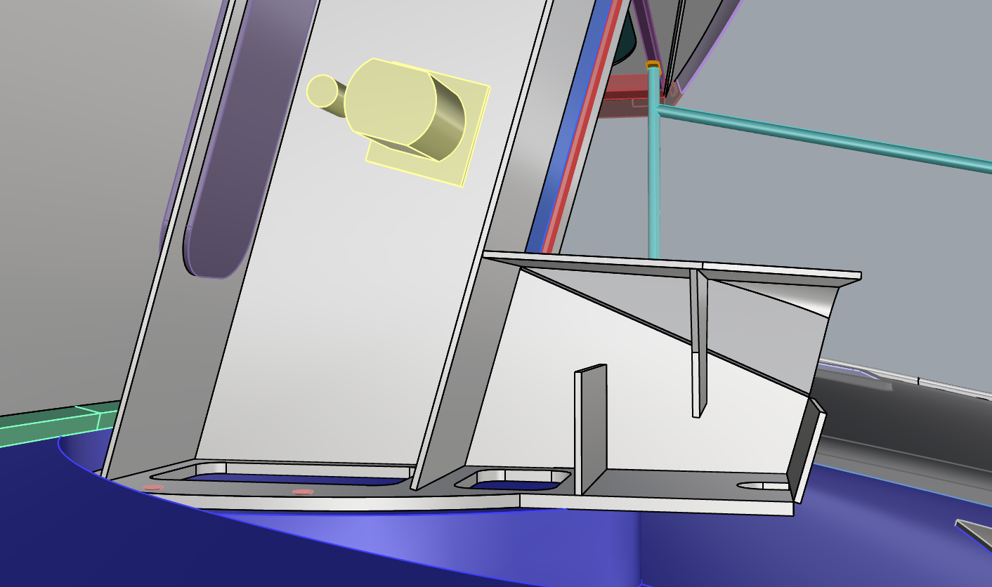
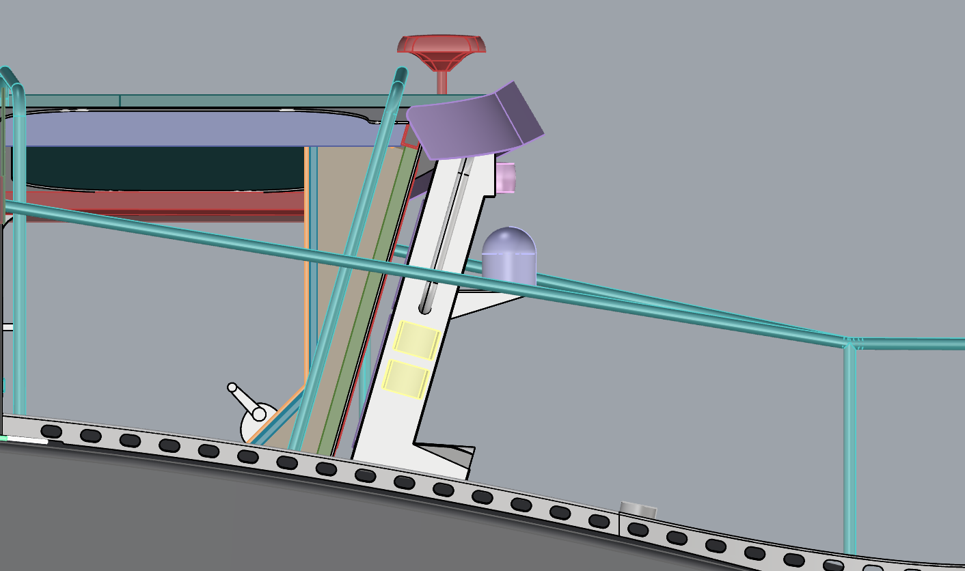
- Small triangular segments of 1.5” OD X ⅛” wall alum. 6061 tube to soften shinwrecker corners.
- Wide cowl opening could be made smaller with a ‘border plate’ or covered with a grille or grate.
- The top face of the dorade cowl/box is angled down forward slightly, 4 degrees, hopefully to roll condensation droplets to the forward drainage area rather than into the battery compartment.

14 MAY 2026

High vent, separate conduit
HV1:
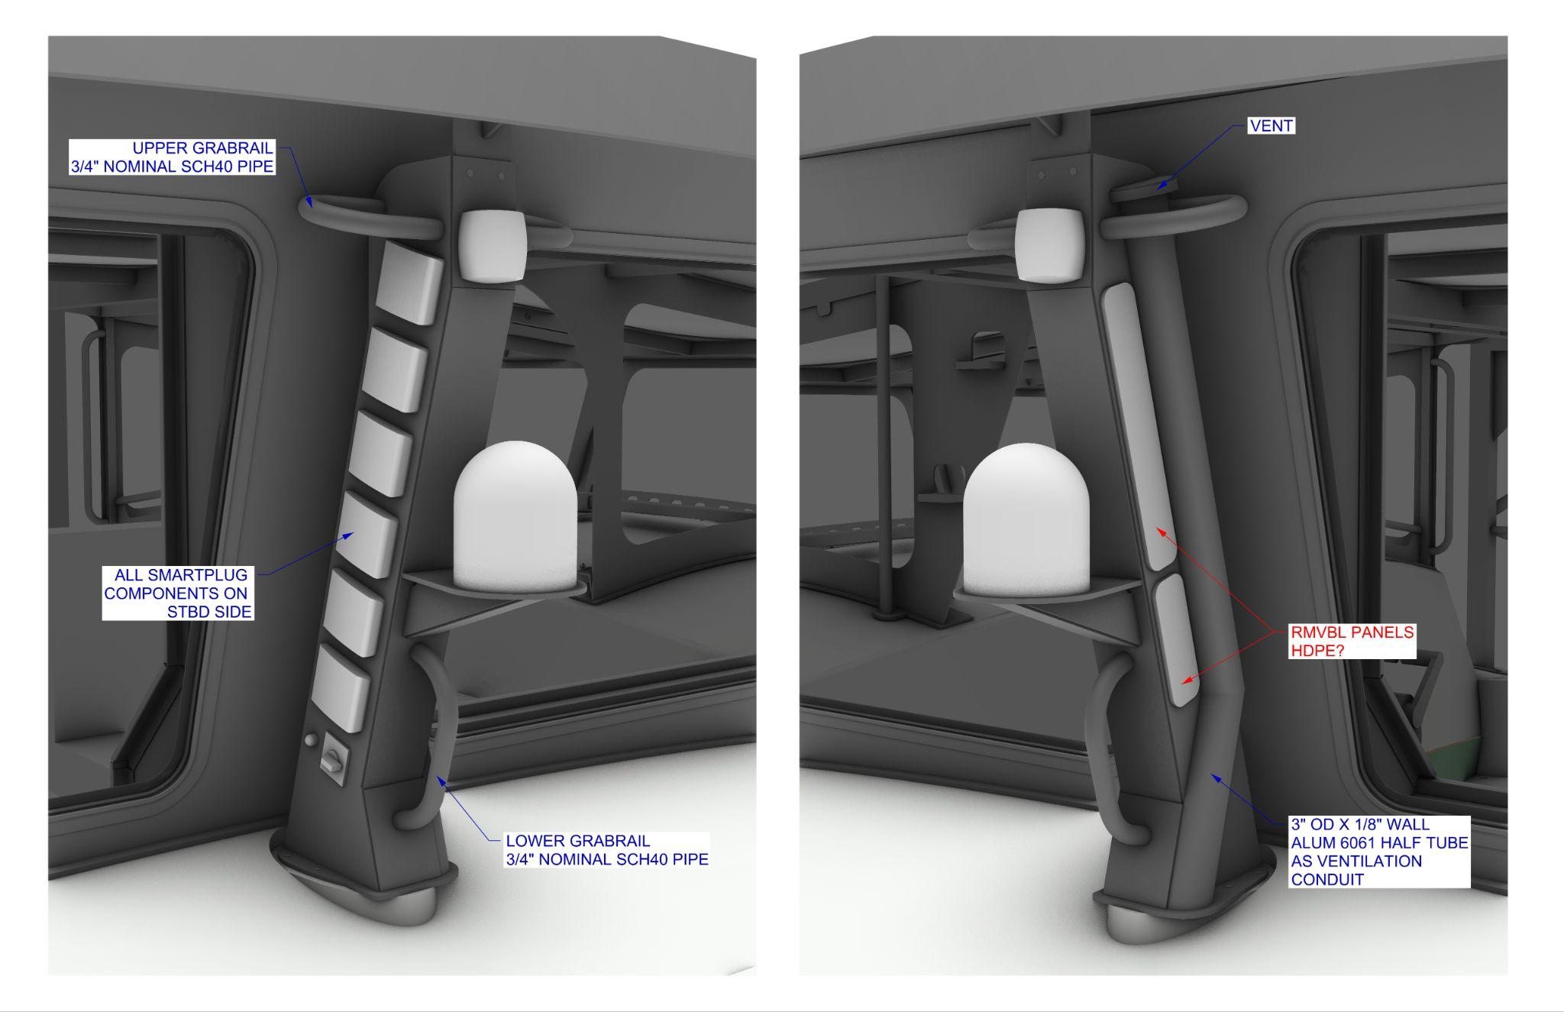
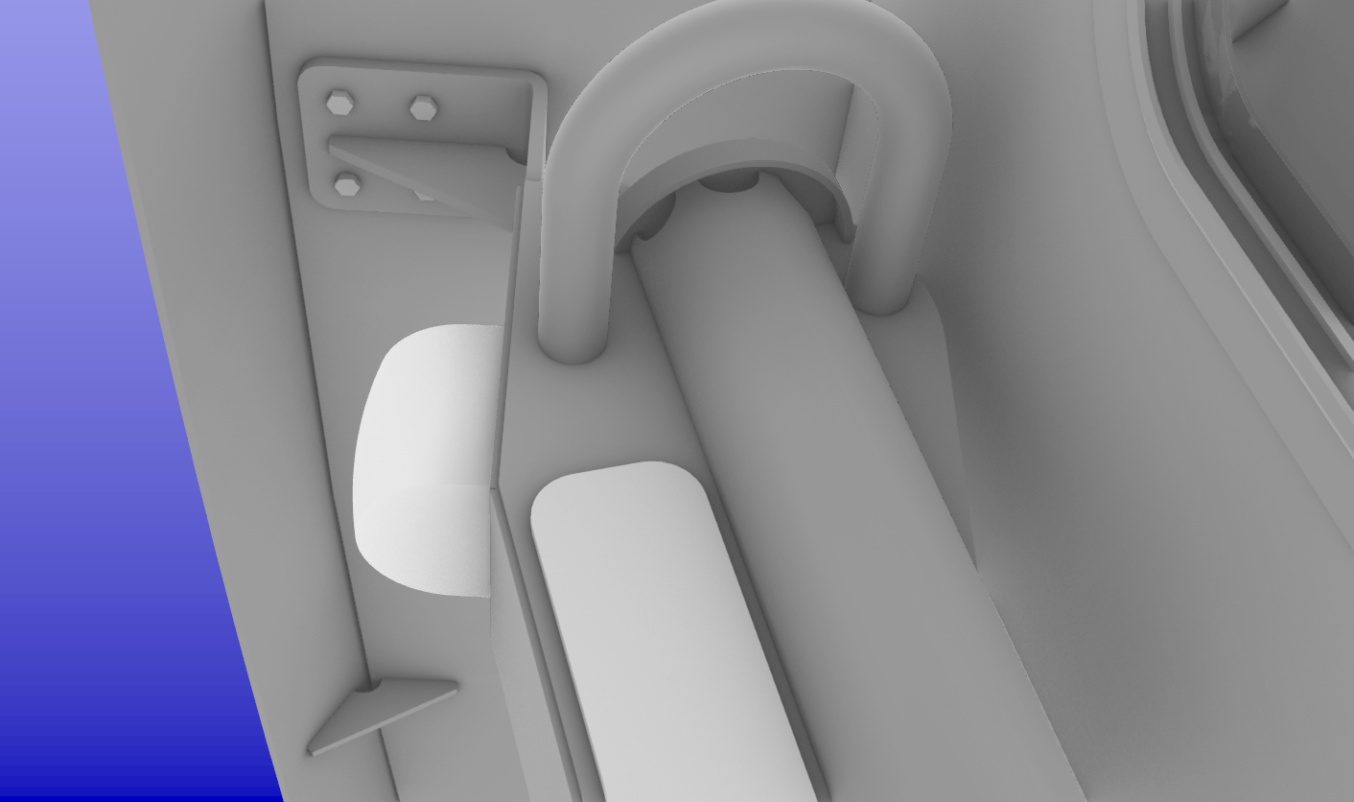
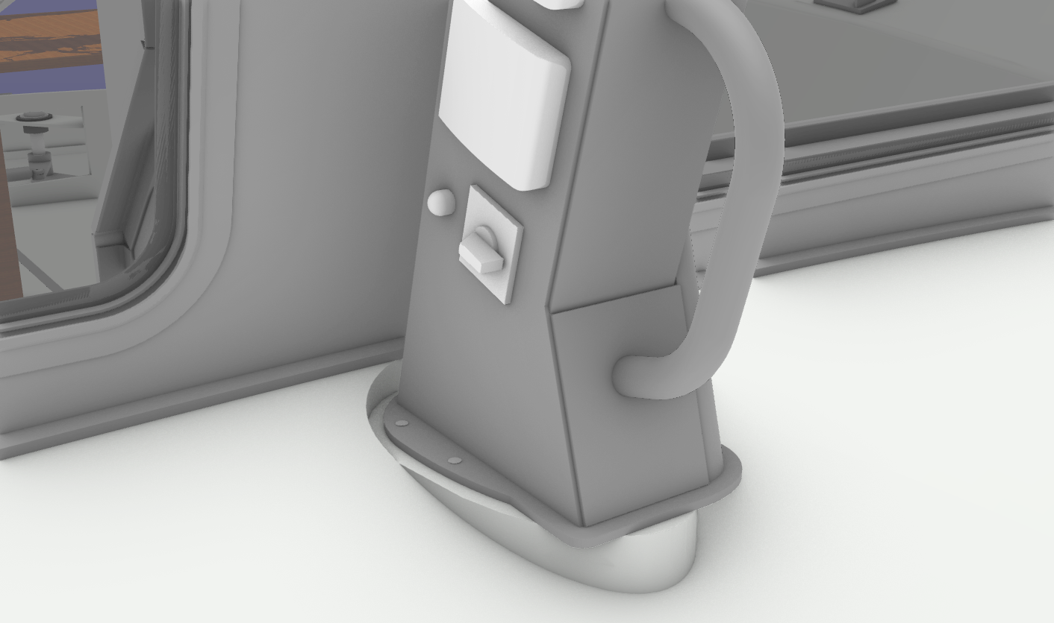
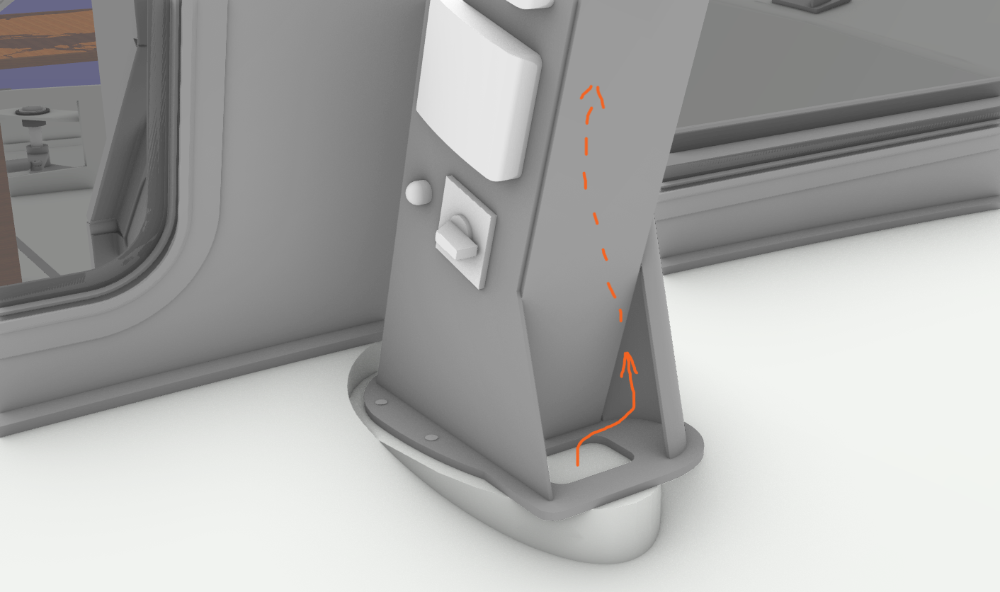

18 MAY 2026

HV2
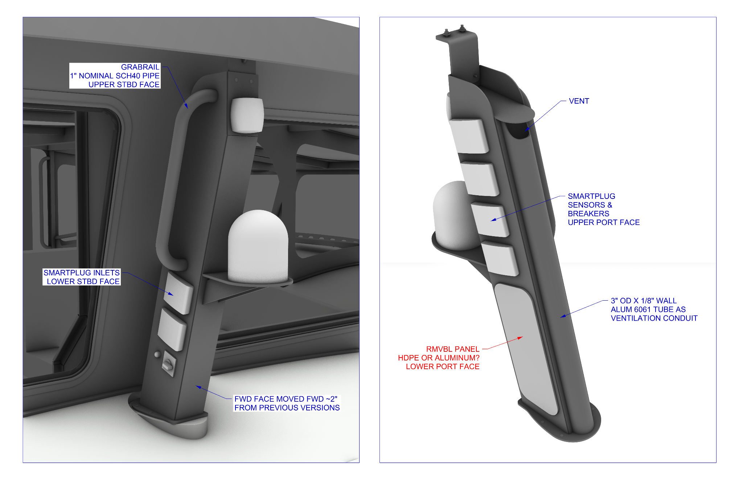
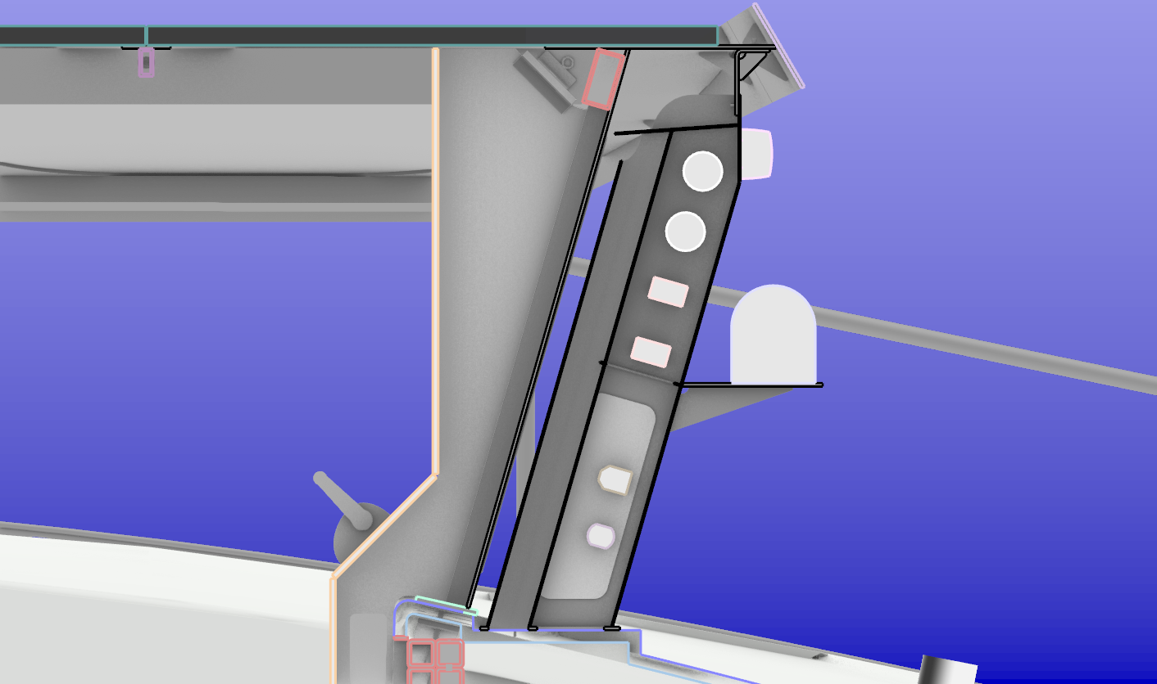
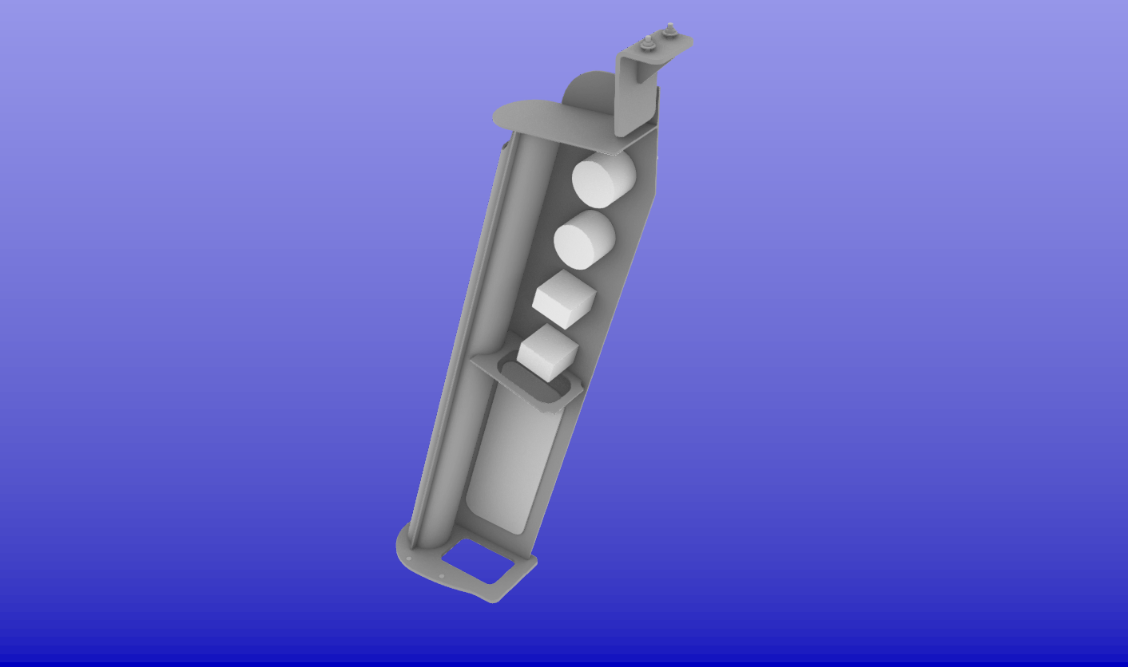
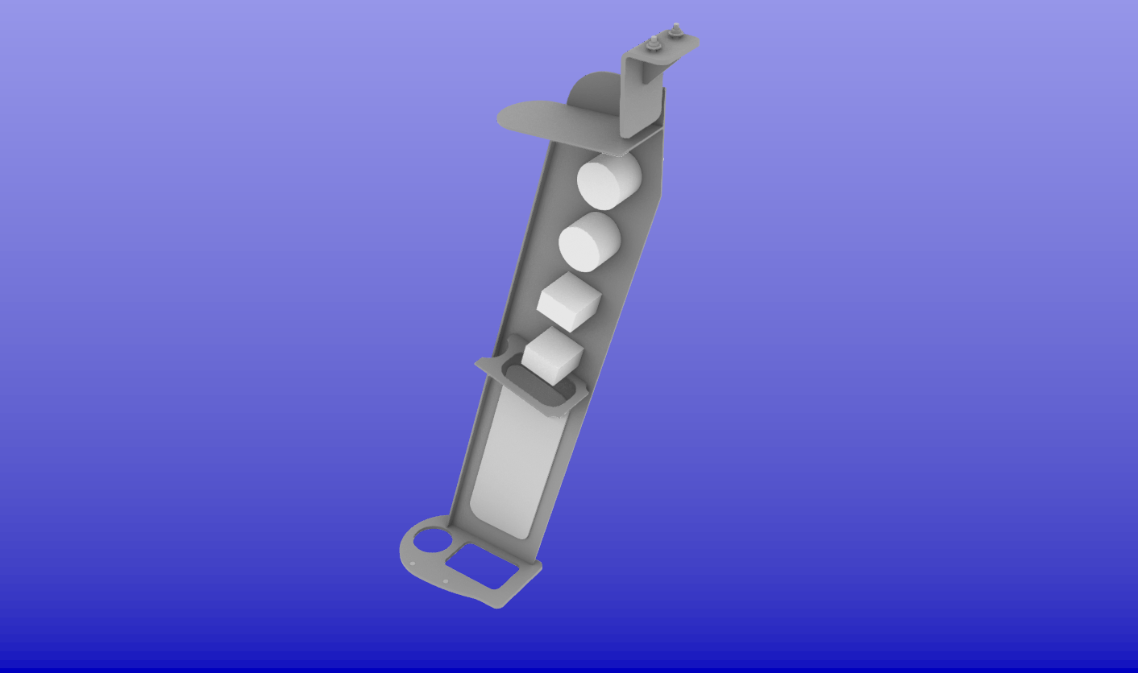
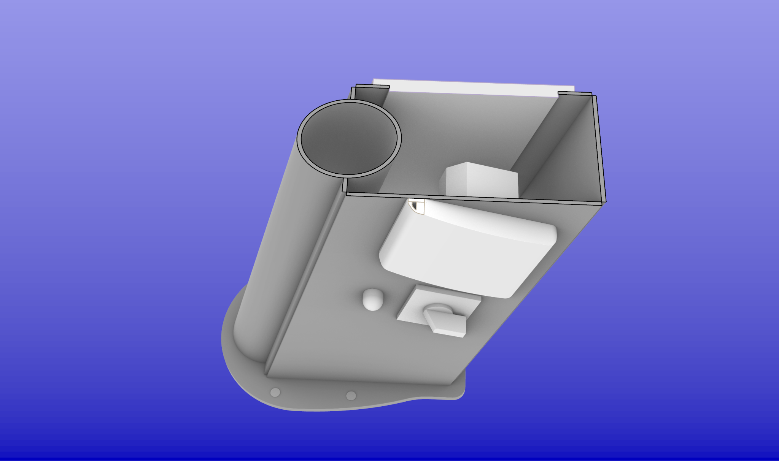
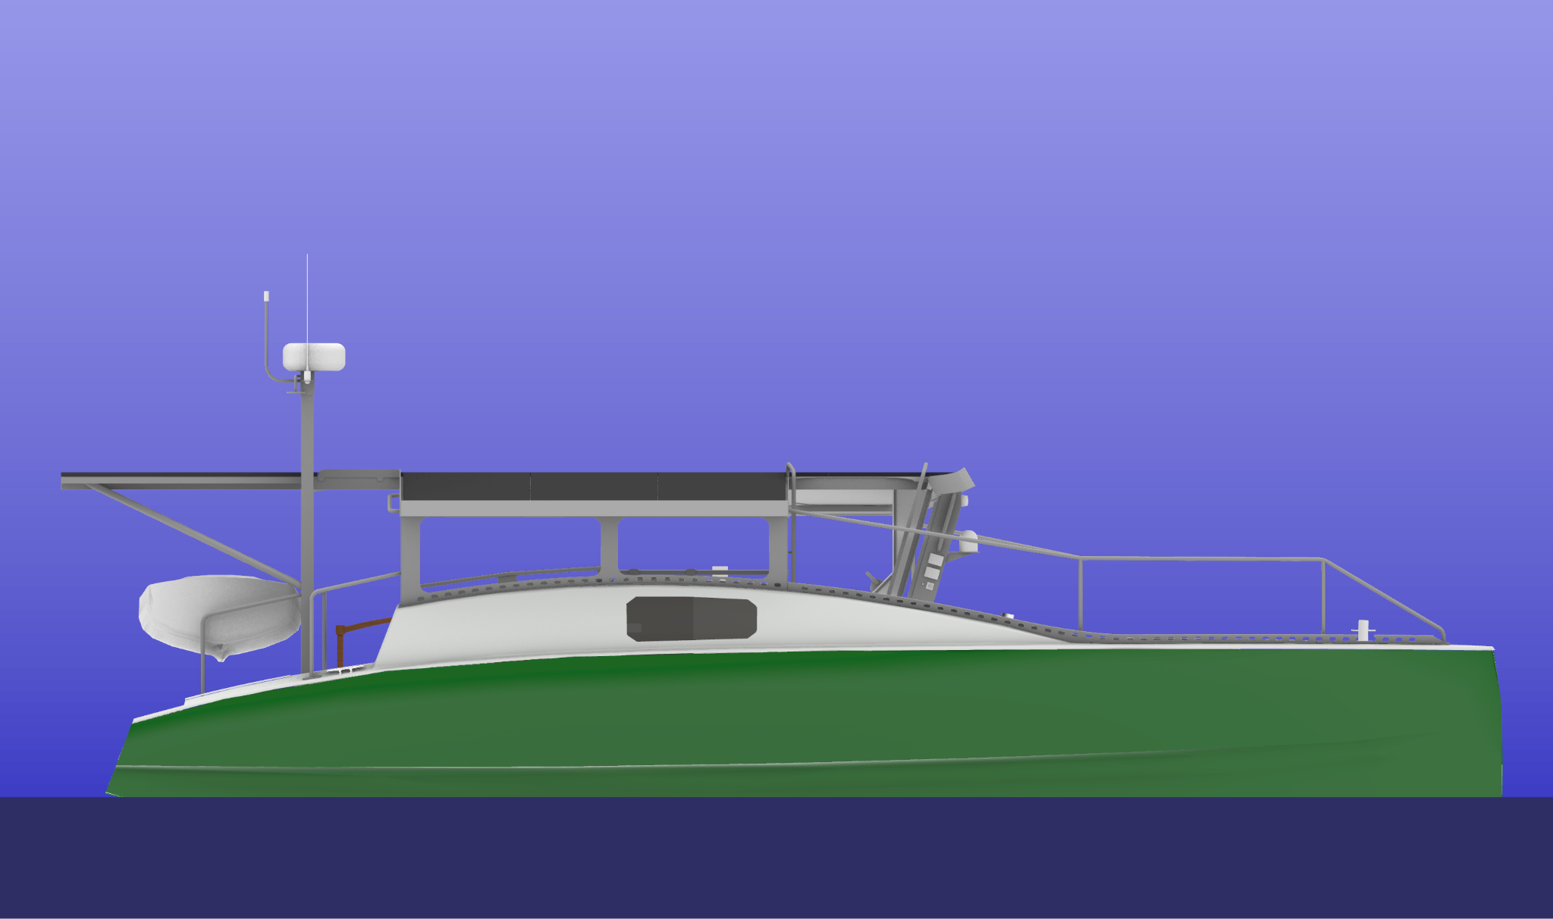

Link to working model
https://drive.google.com/file/d/10PnrBGImLlItbQPLyUXRxRw1BHJn3xFp/view?usp=sharing

